Stripers Landing 1953, 2009, 2021 info

Stripers Landing Central Water System - **1953**

These plans show Stripers Rd. It has since been changed to Stripers Ln.

Bluewater Dr and Va Route 942 are one and the same.

Red Fin Ln and Va Route 1428 are one and the same.

Shad Run Dr and Va Route 1427 are one and the same.

Strippers Ln and Va Route 1426 are one and the same.

Bluewater Dr,

VA ROUTE 942,

Red Fin Ln,

VA ROUTE 1428,

Shad Run Dr,

VA ROUTE 1427,

Stripers Ln,

VA ROUTE 1426

These plans show Stripers Rd. It has since been changed to Stripers Ln.

T# 0470906400-Well Lot, across from 136 Stripers Ln, owned by Stripers Landing Water Company

T# 0470906800-adjacent to west side of lot addressed 50 Stripers Ln, owned by Stripers Landing Water Company

T# 0470906900-Well Lot, addressed 136 Stripers Ln, owned by Western Virginia Water Authority

T# 0470907000-across from 195 Stripers Ln, owned by Stripers Landing Water Company

T# 0470907700-Well Lot, adjacent to west side of lot addressed 350 Stripers Ln, owned by Stripers Landing Water Company

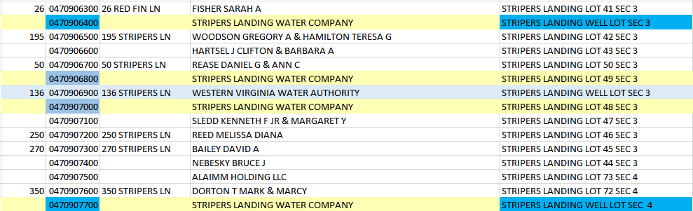

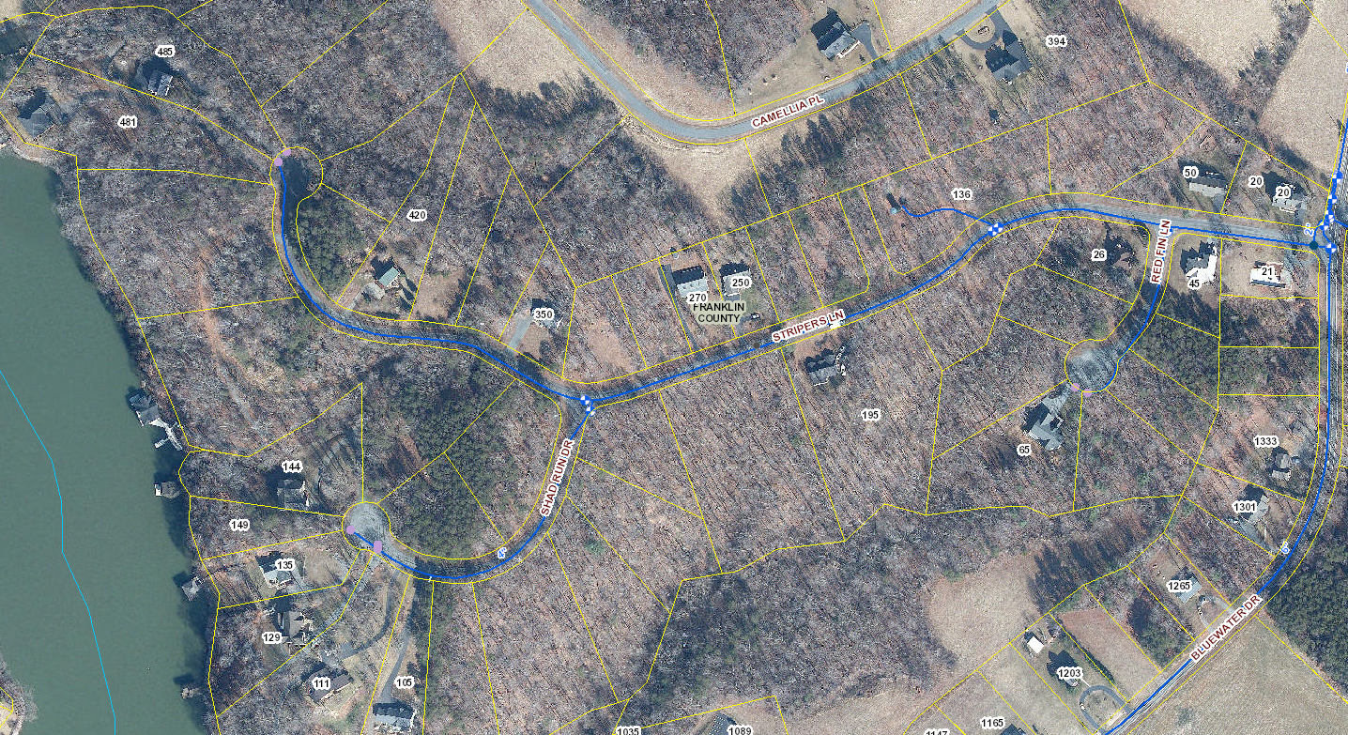  
Bluewater Dr and Va Route 942 are one and the same.  
Red Fin Ln and Va Route 1428 are one and the same.   
Shad Run Dr and Va Route 1427 are one and the same.  
Strippers Ln and Va Route 1426 are one and the same.

T# 0470907700, 300Blk of Stripers Ln, Well Lot owned by Stripers Landing Water Company

T# 0470907000 owned by Stripers Landing Water Company

T# 0470906900, addressed 136 Stripers Ln, Well Lot owned by Western Virginia Water Authority

#T 0470906400 – Well Lot owned by Stripers Landing Water Company

T# 0470906800 owned by Stripers Landing Water Company

STRIPERS LANDING-**2009**

Bluewater Dr,

VA ROUTE 942,

Red Fin Ln,

Shade Run Dr,

Strippers Ln,

VA ROUTE 1426

Bluewater Dr and Va Route 942 are one and the same.

Strippers Ln and Va Route 1426 are one and the same.

---------------------------------------------------------------------------------------------

STRIPERS LANDING-**2021**

Brown Points Dr,

VA ROUTE 1273,

Rolling Rd,

VA ROUTE 941,

Scruggs Rd,

VA ROUTE 616,

Stripers Landing Rd,

VA ROUTE 1650,

Taras Way,

VA ROUTE 1656,

Woodfield Ln (private)

Contractor-Western Virginia Water Authority Field Ops.

8inch DR11 HDPE water pipe installed.

Bluewater Dr and Va Route 942 are one and the same.  
Brown Points Dr and Va Route 1273 are one and the same.  
Rolling Rd and Va Route 941 are one and the same.  
Scruggs Rd and Va Route 616 are one and the same.  
Stripers Landing Rd and Va Route 1650 are one and the same.  
Strippers Ln and Va Route 1426 are one and the same.  
Taras Way and Va Route 1656 are one and the same.