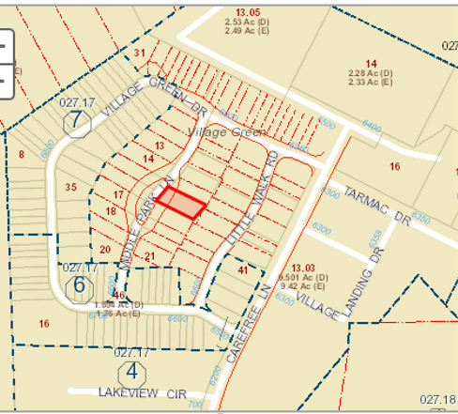

**Plats** for Village Green:

ID#xxxx **Linked:** Instrument # 2010-08983-Village Green Phase 1 (2010)

ID#xxxx **Linked:** Instrument # 2013-11579-Village Green Phase 2 (2013)

ID#xxxx **:** Instrument # ?- Village Green Phase 3 (20??)

ID#4667 **Linked:** Instrument # 201906039-Village Green Phase 4 (2019)

ID#4746 **:** Instrument # 201908773-Village Green Phase 5 (2019)

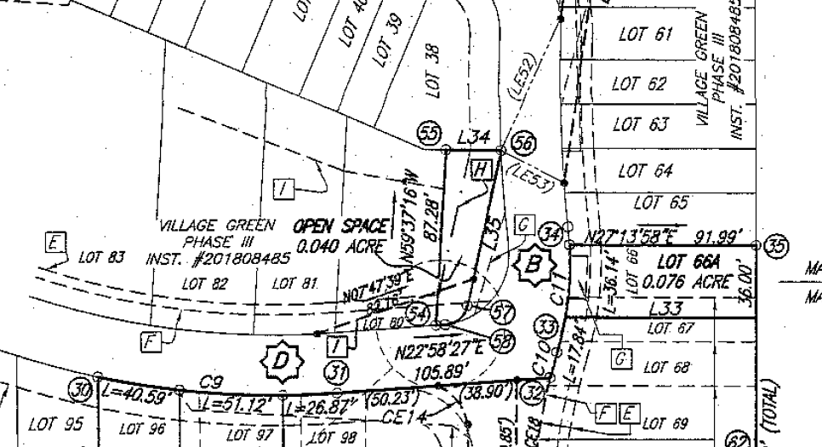

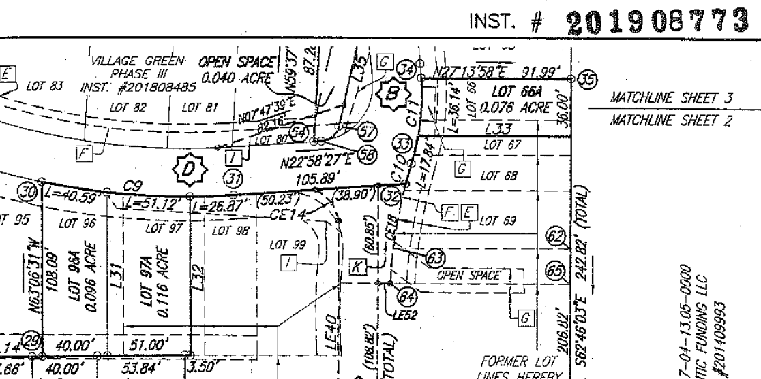

**Phase 5 - Plat**

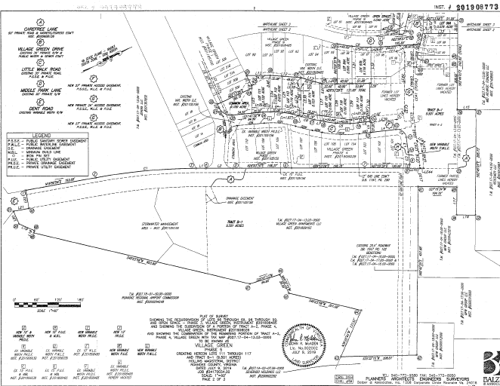

**Phase 5 - Plat**

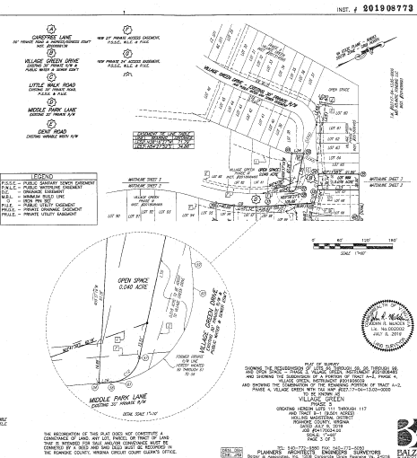

**ID# 4667 Phase 4 Plat** 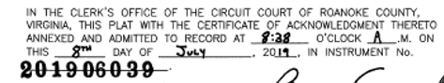

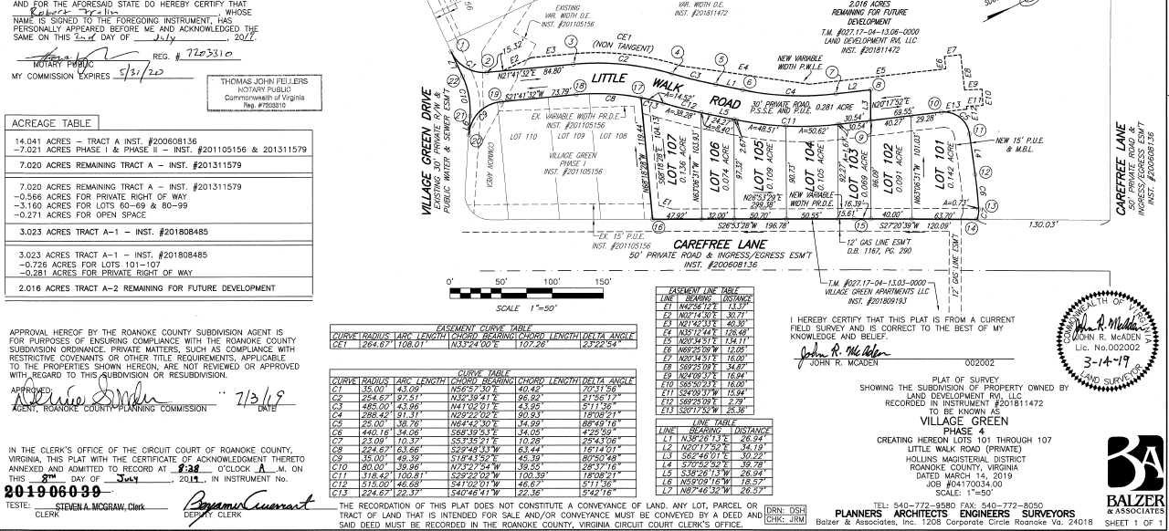

**Phase 2 - Plat**

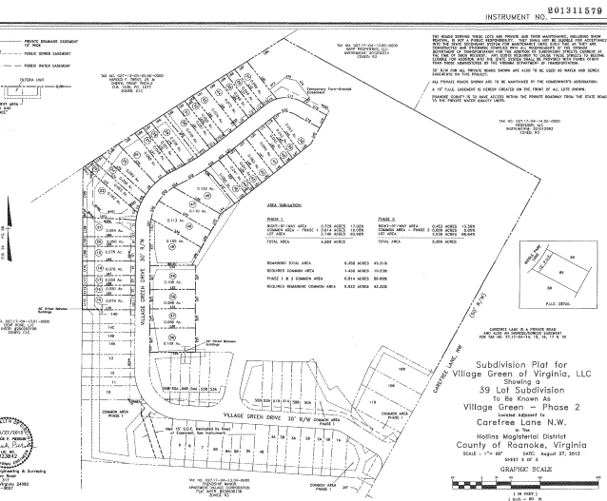

**Phase 1 - Plat**

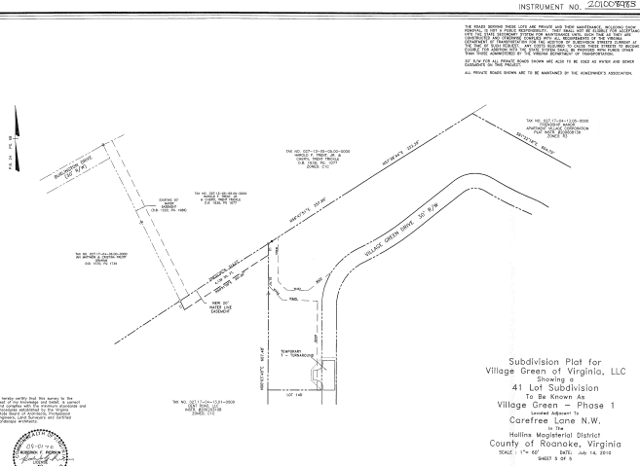

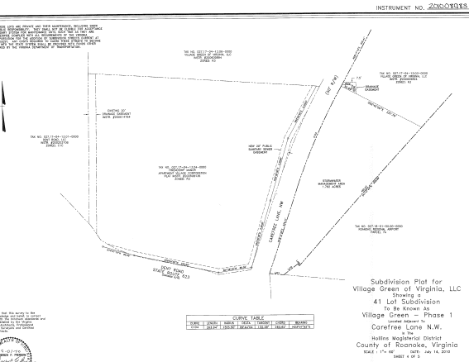

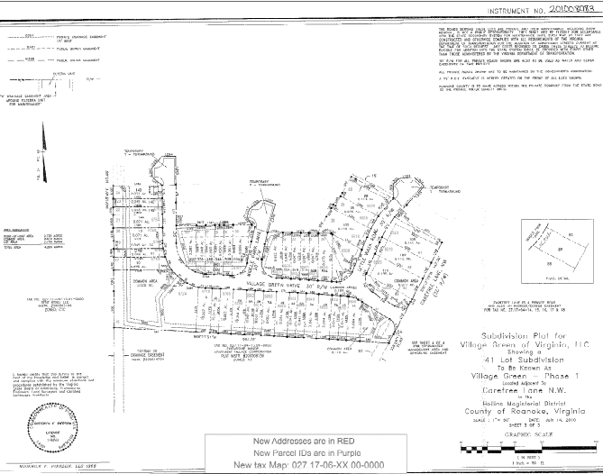

**Phase 1-Site Plan**

