Carvins Cove

Location of this info:

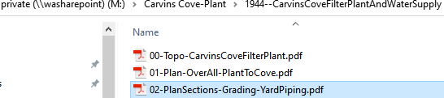

Sheet 2 Grading & Yard Piping

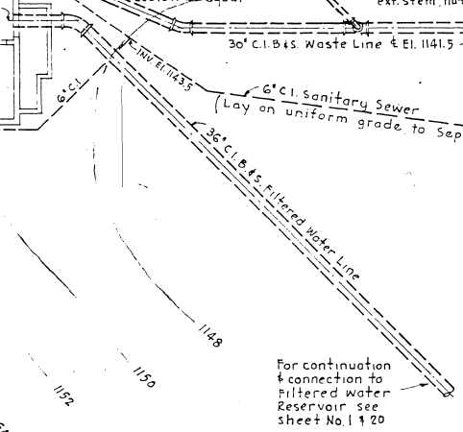C.I.=Cast Iron

B. & S.= In a bell and spigot joint[[2]](https://en.wikipedia.org/wiki/Cast_iron_pipe#cite_note-2) one end of the pipe stick is flared, termed the bell or socket, to enable the opposite end of the next stick, the spigot end, to be inserted to create a joint. The gaps in these joints were stuffed with [oakum](https://en.wikipedia.org/wiki/Oakum) or yarn to retain molten-lead, which solidified into a waterproof joint.

also B. & S.= Ball-and-socket joints introduced more 'rounded' sockets

I looked up this site:



See if there is other info that may help you.