Table of Contents
STATEMENT OF ADOPTION 3
EXECUTIVE SUMMARY 4
ACKNOWLEDGEMENTS 6
1.0 INTRODUCTION 7
1.1 Background 8
1.2 Objectives 8
2.0 WELLHEAD PROTECTION AREA 9
2.1 Delineation of Wellhead Protection Area 9
2.2 Characteristics of the Wellhead Protection Area 11
2.2.1 Soils 11
2.2.2 Geology 14
2.2.3 Topography 16
2.2.4 Groundwater Resources 18
2.2.5 Surface Water and Watersheds 19
2.3 Characteristics of the Wellhead Protection Area 19
3.0 INVENTORY OF POTENTIAL SOURCES OF CONTAMINATION 24
3.1 Potential Sources of Contamination 24
3.2 Identifying New Potential Sources of Contamination 26
4.0 Wellhead Protection Plan 27
4.1 Measures in Place 27
4.2 Public Education 28
4.3 Recommended Actions 28
5.0 REFERENCES 30

List of Tables
Table 1 - Soil Series, Contentment Island WHPA 13
Table 2 - Key Properties of Soils in the Contentment Island WHPA 13
Table 3 - Geologic Formations within the Wellhead Protection Areas (Henika, 1997) 16
Table 4 - Well Information 21
Table 5 - Land Uses of Concern and Potential Sources of Contamination 25

LIST OF FIGURES
Figure 1 – Potential Sources of Contamination 10
Figure 2 – Soils Map 12
Figure 3 – Geologic Map 15
Figure 4 – Topography and Elevation 17

LIST OF Appendices

Appendix A Soils Descriptions

Appendix B Various Potential Sources of Contamination

Appendix C Educational Materials

Appendix D Sample Emergency Response Plan

STATEMENT OF ADOPTION

Contentment Island adopted this Wellhead Protection Plan and has a copy of the plan on file with the Virginia Department of Health. The service and assistance of the members of the Source Water Protection Planning Committee in preparation of the plan is acknowledged and greatly appreciated.

Gary Robertson, P.E. | Executive Director, Water Operations
Bob Benninger, P.E. | Director of Water Operations
Sarah Baumgardener | Environmental Communications Coordinator
Travis Jones | Water Distribution Manager

By signing below, we acknowledge the above statements to be true, and that we are authorized by Contentment Island to make such representation.

Name, Title Date

Name, Secretary of Board or Other Witness Date

EXECUTIVE SUMMARY
Maintaining high-quality drinking water supplies is the primary goal of source water protection efforts under the Safe Drinking Water Act. The 1986 Amendments to the Safe Drinking Water Act established the Wellhead Protection Program. As defined by this program, the wellhead protection planning process includes the following elements:
- Identifying the area’s public water supply wells;
- Assessing the potential risks to groundwater in areas around these wells; and
- Implementing measures to manage these risks and prevent groundwater problems.

The Contentment Island water system consists of three online wells, disinfection treatment, a 36,400- gallon standpipe atmospheric tank, disinfection system, , and distribution system that serves approximately 85 residential connections within the subdivision. The land surrounding the water system is sparsely developed and includes low-density residential uses, woodlands, and limited agricultural uses.

The Contentment Island water system is fed by groundwater flowing primarily through a network of faults and fractures in the igneous and metamorphic geology underlying the wellhead protection area (WHPA). Key concerns as potential sources of contamination in the recharge zone (the wellhead Protection Area) include: on-site septic systems; private wells; and residential use of fertilizers, pesticides, chemicals, and petroleum.

The Local Advisory Committee (LAC) for this source water protection plan developed the following recommended actions to help ensure the availability and quality of the Contentment Island water supply into the future:

- Develop a brochure describing Source Water Protection specifically for the Contentment Island water system and promote the general education of the community on Wellhead Protection.
- Attach wellhead protection articles to water bills, POA, or community newsletters.
- Develop business cards to hand out to residents with questions about wellhead protection.
- Pair Wellhead Protection information with Cross Connection Control Surveys to identify other potential sources of contamination.
- Mail the water system brochure to each residence in the Wellhead Protection Area (WHPA). Septic system informational brochures (developed by the EPA) will be included in the mailing to those homes that may have a septic system.
- Hold an annual meeting between the water operators and the Property Owner’s Association members to discuss wellhead protection information and activities in the community.
- Install signs along the roadway in high visibility locations near to the designated boundary of the wellhead protection area that state “Entering a Source Water Protection Area”.
- Annually review with pertinent emergency response personnel the designated WHPA zone and appropriate response procedures. Provide emergency information sheet that shows the WHPA, roads, and emergency contact information.
- Annually review and update the WHPP.

ACKNOWLEDGEMENTS
The Wellhead Protection Plan for the Contentment Island water system meets all requirements of the Commonwealth of Virginia’s Wellhead Protection Program. These requirements include delineating the Wellhead Protection Area (WHPA), identifying potential sources of contamination within the protection area and creating an inventory of these sources, and conducting a susceptibility analysis to determine the risk of contamination to the water source. The Wellhead Protection Plan builds on the Source Water Assessment Report and develops a plan for protecting groundwater from contamination.

A Local Advisory Committee (LAC) was formed to develop and implement this Wellhead Protection Plan for the Contentment Island Subdivision water system. LAC members include:

Gary Robertson | Executive Director, Water Operations
Bob Benninger | P.E., Director of Water Operations
Sarah Baumgardener | Environmental Communications Coordinator
Travis Jones | Water Operator

These LAC members provided direction, knowledge, and experience to assist the planning process. The Virginia Department of Health and Olver – A CHA Company recognize the contributions and dedication of LAC members, and thank them for their efforts.

The Contentment Island Wellhead Protection Plan effort was funded by the Virginia Department of Health.

INTRODUCTION
Protection of groundwater-based public water supplies is of vital importance to the residents and operators of the Contentment Island Subdivision water system. The public water supply represents a valuable resource and investment which, if it were to become polluted, could negatively impact public health and would be expensive to restore or replace. Once contaminated, a groundwater reservoir may be permanently degraded or require costly augmented remediation. Reducing or preventing chemical and microbiological contamination of source waters could ideally allow public water systems to avoid costly treatments and minimize monitoring requirements. The costs associated with drinking water contamination generally include the following:

- Providing emergency replacement water;
- Paying for treatment and/or remediation expenses;
- Finding and developing new supplies;
- Paying for consulting services and staff time;
- Litigating against responsible parties;
- Conducting public information campaigns when incidents occur;
- Failing to meet the regulations of the Safe Drinking Water Act, such as the Disinfection Byproduct and monitoring requirements;
- Reducing property value or tax revenue;
- Adding health related costs from exposure to contaminated water;
- Loss of production of individuals and businesses that rely on a clean water supply, loss of economic development opportunities; and
- Community objection to use of treated drinking water.

Many normal day-to-day activities could have the unintended consequence of compromising the community’s drinking water supply. Septic systems providing on-site wastewater treatment and improper use or disposal of household chemicals and fuels all have the potential of being sources of contamination when they are in the recharge areas of the public water supply.

Groundwater is vulnerable to contamination by several pathways, including:
- infiltration from the surface
- leachate from onsite wastewater (septic) systems
- injection of contaminants through improperly constructed or defective wells
- direct contamination of groundwater through geologic features
- originating from naturally occurring substances in the soil or rock

The properties of the aquifer and overlying soils affect the movement of contaminants. Preventing contamination is the key to keeping groundwater supplies safe.

Background
This Wellhead Protection Plan’s main focus is to develop and implement a plan to ensure that the Contentment Island Subdivision water system will continue to provide high quality water to its customers in the present and future. The Wellhead Protection Plan builds on the information contained in the Source Water Assessment completed by the Virginia Department of Health (2002).

The Contentment Island water system consists of three online wells, a disinfection treatment, and 36,400- gallon standpipe atmospheric tank. The disinfection system is a sodium hypochlorite-based system and soda ash is used for corrosion control, within the subdivision. The water system serves approximately 85 residential connections on a peninsula of land surrounded by Smith Mountain Lake (see Figure 1). The estimated total usage for this water system is 8,500 gallons/day.

Water from the Contentment Island water system wells meets all standards for drinking water. There have not been any positive bacteriological samples or Primary Drinking Water Regulations Maximum Containment Level (PMCL) exceedances associated with the Contentment Island water system. Prior to Western Virginia Water Authority owning the Contentment Island waterworks, several Notices of Violation (NOV) were received by the waterworks. The NOVs were related to monitoring and reporting requirement violations and were not considered health based violations.

Objectives
The objectives of the Contentment Island Wellhead Protection Plan are:
- To promote public health, economic development and community infrastructure by maintaining an adequate drinking water supply for all residents of the community and region, both now and into the future;
- To protect groundwater from the threat of contamination as a result of accidents or unwise practices from nearby residential, industrial, commercial, agricultural, waste management, or transportation activities; and
- To cooperate with the Virginia Department of Health in carrying out the Safe Drinking Water Act purposes and provisions.

WELLHEAD PROTECTION AREA

Delineation of Wellhead Protection Area
The Wellhead Protection Area (WHPA; also referred to as the Source Water Protection Area) is the area that must be considered by Contentment Island to protect groundwater resources. The WHPA is defined as the surface or subsurface area surrounding the water well, through which contaminants – if present - are reasonably likely to move toward and reach the water well. The WHPA was delineated as part of the source water assessment program based on a fixed radius around each of the wells supplying the Contentment Island Subdivision water system. The assessment considers two different zones:
- Zone 1 is a 1000 foot radius around the well and is a priority zone for managing potential sources of contamination; and
- Zone 2 is a one-mile (5,280-foot) radius which represents an estimate of the total recharge zone for the well.

Figure 1 provides a map of the Contentment Island WHPAs. The land surrounding the Contentment Island water system is sparsely developed and includes low-density residential uses, woodlands, and limited agricultural uses. Much of the WHPA consists of open space including shoreline (along Smith Mountain Lake), fields, and pasture uses.

The recharge zone, also called the contributing zone, is the area of land where water flowing downward to recharge the aquifer will eventually be captured and removed by the pumping well. The fixed-radius approach to delineating the recharge zone is used as a reasonable approximation of the recharge zone.

A more specific delineation of the recharge zone could be developed through a more extensive evaluation of factors such as the hydrogeology in the vicinity of the well, daily withdrawal rate of the well, watershed boundaries, topography, bedrock and surficial geology, permeability and hydraulic conductivity of the bedrock structural geology, flow boundaries such as ridges, rivers, canals and lakes, fracture traces and lineaments, and dissolution features such as sinkholes. A specific delineation study as described above may be cost prohibitive; therefore, the 1-mile radius is used as a conservative approach in lieu of additional studies.

Figure 1 – Potential Sources of Contamination

Characteristics of the Wellhead Protection Area

Soils
Soils characteristics play an important role in determining groundwater infiltration rates and groundwater quality, and in affecting the chemical quality of groundwater resources.

Soils with higher clay and/or organic matter content will more readily adsorb contaminants such as pesticides and metals than soils with low clay and/or organic content.

Soil depth, infiltration rate, and drainage are also important factors that influence the likelihood of groundwater contamination to occur following a release into the environment. In general, deeper soils retain water and contaminants for a greater duration than shallower soils. In general, well-sorted soils have the greatest porosity and coarse, highly sorted soils are most permeable. These soils will readily transmit water. Poorly sorted soils are less porous, and fine or poorly sorted soils are less permeable. A soil with larger particles (sand or silt) will transmit water and contaminants more readily than a soil with smaller particles (clays). Both soil depth and particle size influence a soil’s drainage characteristics.

A detailed soil map has been prepared for the area surrounding the Contentment Island water system, using spatial data from the USDA Soil Conservation Service. This map is provided as Figure 2.

There are five major soil series located within the Contentment Island WHPA. Table 1 identifies these soils and is meant to supplement the corresponding map labels in Figure 2. Table 2 summarizes several key characteristics of each soil. More specific soil descriptions are included in Appendix A.

Figure 2 – Soils Map

Table 1 - Soil Series, Contentment Island WHPA
Map Unit | Soil Unit
3 | Bluemount-Redbrush-Spriggs complex
7 | Clifford Fine Sandy Loam
8 | Clifford-Hickoryknob Complex
24 | Jackland-Mirerock-Redbrush complex
28 | Minnieville-Orenda-Redbrush complex
Source: USDA Web Soil Survey.

Table 2 - Key Properties of Soils in the Contentment Island WHPA
Soil Series | Slope | Depth Class | Drainage | Permeability | %  Organic Matter | %  Clay
Bluemount-Redbrush-Spriggs complex | 15-25% | Very Deep | Well Drained | Moderately Slow to Moderate | 0.41 | 25.7
Clifford Fine Sandy Loam | 2-25% | Very Deep | Well Drained | Moderate | 0.40 | 25.0
Clifford-Hickoryknob Complex | 15-45% | Very Deep | Well Drained | Moderate | 0.40 | 25.0
Jackland-Mirerock-Redbrush complex | 2-15% | Very Deep | Somewhat Poorly Drained | Very Slow to Moderate | 0.32 | 39.1
Minnieville-Orenda-Redbrush complex | 8-25% | Very Deep | Well Drained | Moderately Slow | 0.30 | 45.0
Source: USDA Web Soil Survey.

All soils located in the WHPA are very deep, and this characteristic is favorable for maintaining water quality because deeper soils have greater capacity to adsorb potential groundwater contaminants that are released into the environment. Deep soils, however, may retain potential contaminants for an extended time, thereby delaying detection and extending the release of contamination.

Soils in the WHPA are mostly well drained, and permeability is generally moderately slow to moderate for the soils listed. Organic matter and clay content vary by soil type and are considered moderate throughout the WHPA.

Soils in the WHPA provide depth, permeability and physical/chemical characteristics that are favorable for maintaining groundwater quality and quantity.

Geology
The geological features of the region dictate the availability, rate of flow, and quality of the groundwater. Different types of rock have different physical characteristics, which play important roles in governing the availability and rate of flow in the aquifer.

The Contentment Island water system is located within the Piedmont Physiographic Province of Virginia (Bailey, 1999). The rock in the study area is primarily igneous and metamorphic; groundwater flow is primarily through secondary features, such as joints, fractures, faults, etc. In general, the amount of fracturing and degree of fracture interconnection and fracture zone permeability strongly influence the yield that can be recovered from a well. In the Piedmont, the size and number of water-bearing fractures in the bedrock generally decrease with depth, so significant water supplies are typically limited to within a few hundred feet of the surface (VWRRC, 1999).

Figure 3 displays the subsurface geology in the vicinity of the Contentment Island WHPA. The 1000-ft radius around all of the wells is directly underlain by the Alligator Back Formation (mica gneiss, mica schist, and quartzite). The Alligator Back Formation dominates the one mile radius of the wells, with isolated areas of the Ashe Formation (biotite gneiss and schist, feldspar, quartz, and granite) located in the northwestern section of the 1-mile radii of the wells and the Amphibolite Schist Member of the Fries Thrust Sheet located in the northeast section of the 1-mile radii of the wells.

Table 3 describes each of these formations in more detail.
Figure 3 – Geologic Map

Table 3 - Geologic Formations within the Wellhead Protection Areas (Henika, 1997)
Formation Name | Description
Alligator Back Formation – Feldspathic Metagraywacke  (CZmy) | Laminated mica gneiss (metagraywacke), medium- to light-gray, fine- to medium- grained, mica schist, quartzite, calc-gneiss, graphitic phyllite, marble, blue-quartz-granule and metacomglomerate beds; thin partings of dark-greenish-gray, actinolite schist (metabalast).
Alligator Back Formation – Actinolite Schist  (CZas) | Actinolite schist (metabalast); dark-greenish gray to light-yellowish-green. Quartz-epidote granofels, tuffaceous meta-sandstone layers with thin interlayered quartz-mica phyllite, quartzite, metagraywacke, calc-silicate beds, and lens shaped deposits of white and pink marble.
Ashe Formation  (Zam) | Biotite gneiss and schist, medium- to light-gray, coarse- to very coarse-grained, thick-bedded to structureless. Conglomeratic with feldspar, quartz, and granitic clasts probably equivalent to Rockfish Conglomerate to the northeast along the margins of the rift; grades upward into medium- to fine-grained, salt and pepper textured, two-mica plagioclase gneiss with mica gneiss interbeds. Intergradational along strike with metavolcanic rocks of an Iapetan rift basin (Moneta Gneiss).
Amphibolite and Schist (CZmi) | Amphibolite, dark-greenish to black, coarse-granoblastic, intergradations with greenish-gray, fine grained nematoblastic chlroite-amphibole schist, untramafic schist, or soapstone in complex metamorphosed stratiform igneous plutons.

The Contentment Island water system is fed by groundwater flowing primarily through a network of faults and fractures in the igneous and metamorphic geology underlying the WHPA. Because the production wells are located at a topographic high, the recharge to the groundwater flow is likely in close proximity to the wells. Subsurface geology in the WHPA has proven sufficient to support the Contentment Island system’s capacity. The mineral composition of parent bedrock in the WHPA is favorable for the presence of high-quality groundwater.

Topography

Figure 4 shows the topography and elevation contours for the Contentment Island Subdivision WHPA. Contentment Island’s wells #1, 2, 3, and 4 are located at slightly higher elevations than much of the immediately surrounding topography. Recharge zones for the wells are primarily

Figure 4 – Topography and Elevation

located at elevations higher than those of each well’s open borehole interval, in the immediate area. The wells have an open borehole from approximately 70-ft to 400-ft below ground surface, making the elevations of the open boreholes approximately 830-500-ft above sea level. The elevation of the lake is approximately 795-ft above sea level.

Groundwater Resources
Groundwater occurrence within Franklin County is primarily controlled by topography and the subsurface geologic structures. A complex formation of Precambrian crystalline rocks underlies the County resulting in some of the poorest water production within the state. Groundwater in this type of rock is only found in the fractured zone in the upper levels (within a few hundred feet of the surface) of the rock. Due to the extremely limited supply of water in the shattered rock formation, heavy pumping often results in dramatically fluctuating water levels (Franklin County BOS, 2007).

With the exception of the Town of Rocky Mount, which has a public surface water supply serving ~7,000 people and several large industries, the remainder of the County relies on groundwater. In most cases, the supply and quality of water is adequate. Because development in the County is often dependent on individual homeowner’s wells and community well systems, the County is concerned with protecting groundwater sources (Franklin County BOS, 2007).

Well yields in the Piedmont generally range from 3 to 20 gallons per minute, although higher yields are possible in areas with extensive faulting or fracture, or at lower (valley) elevations. In general, the potential for ground water pollution is considered low to moderate in the Piedmont (VWRRC 1999).

Groundwater recharge in the Blackwater River watershed near Union Hall, VA is estimated to be approximately 10.42 inches/year (USGS, 2009). Based on the average daily water usage for the system of 8,500 gallons/day (3,102,500 gallons/year), then a recharge area of approximately 11 acres (479,200 square feet) would be required to supply groundwater to the water system wells. The 1,000-ft radius surrounding the wells (Zone 1) is approximately 72 acres.

Surface Water and Watersheds
The Contentment Island water system is located in the Lower Blackwater River/Smith Mountain Lake watershed (BOS, 2007) part of the Roanoke River watershed.

Contentment Island Subdivision’s wells tap into groundwater flowing through bedrock faults and fractures far below the surface. Although the subdivision is a peninsula that is bounded on three sides by Smith Mountain Lake, it not located within an alluvial recharge-discharge interface, in which groundwater would be found at relatively shallow depths and shares a direct hydrologic linkage with a surface water body. Accordingly, the Contentment Island system provides lower yields but more consistent quality than if it were more closely associated with surface water features.

Characteristics of the WATERWORKS
The Contentment Island water system serves 85 residential connections within the subdivision, and the average daily water usage for the system is 8,500 gpd.

Figure 1 provides an aerial image of the well locations and surrounding area. There are three wells utilized by Contentment Island waterworks (Wells # 1, 2, and 4) and one well that is offline (Well #3). Well #1 is located 85 feet west of the Route 957 (Summerwind Drive) in a vinyl-sided building. Well #2 is located 300 feet north of Well #1. Well #3 is located 200-feet west of Well #1. Well #4 is located approximately 85-feet south-southwest of Well #1.

Well #1 was constructed in 1988 and has a depth of 400 feet. The well is cased with a six-inch diameter galvanized steel casing to a depth of 69 feet and is grouted to a depth of 69 feet. A 10 gpm yield and 12 gpm pump delivery rate have been observed. Well #1 is housed in a vinyl-sided building that is provided with a heater, concrete floor, and screened floor drain.

Well #2 was constructed in 1988 and has a depth of 400 feet. The well is cased with a six-inch diameter steel casing to a depth of 64 feet and is grouted to a depth of 64 feet. A 58 gpm yield and 58 gpm pump delivery rate have been observed. Well #2 is provided with a 6-ft X 6-ft X 6-in concrete pad, pitless adapter, and well cap with vent.

Well #3 was constructed in 1989 and has a depth of 400 feet. The well is cased with a six-inch diameter steel casing to a depth of 70 feet and is grouted to a depth of 70 feet. A 47 gpm yield and a 48 gpm pump delivery rate have been observed. Well #3 is provided with a 6-ft X 6-ft X6-in concrete pad, pitless adapter, and well cap with vent. This well is currently not in use.

Well # 4 WVWA needs to provide information,

The treatment equipment is located inside of Well House #1. All water is treated with sodium hypochlorite and soda ash to adjust pH for corrosion control. The 36,400-gallon standpipe atmospheric water tank is located adjacent to the treatment building. The standpipe is 12 feet 6 inches is diameter and 40 feet tall. The effective storage volume of the standpipe is 28,800 gallons.

Table 4 summarizes the characteristics of the Contentment Island subdivision’s wells.

Table 4 - Well Information
Source | Depth (ft) | Yield (gpm) | Pump Capacity (gpm) | Effective Capacity (gpd)
Well #1 | 400 | 10 | 12 | 8,000
Well #2 | 400 | 47 | 48 | 37,600
Well #3 | 400 | 58 | 58 | 46,400
Well #4 | * | * | * | *
* Need info from WVWA
Photograph 1 – Contentment Island Well 1
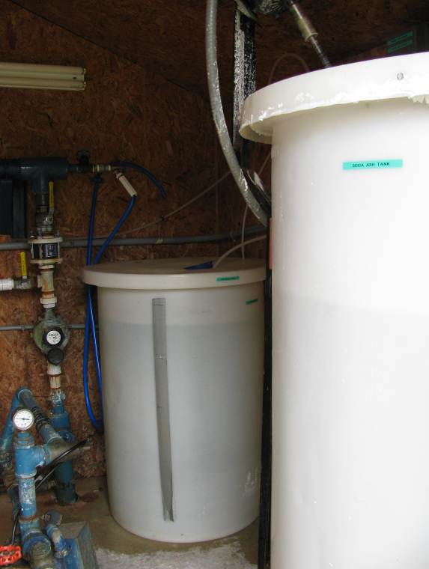

Photograph 2 – Contentment Island Well House
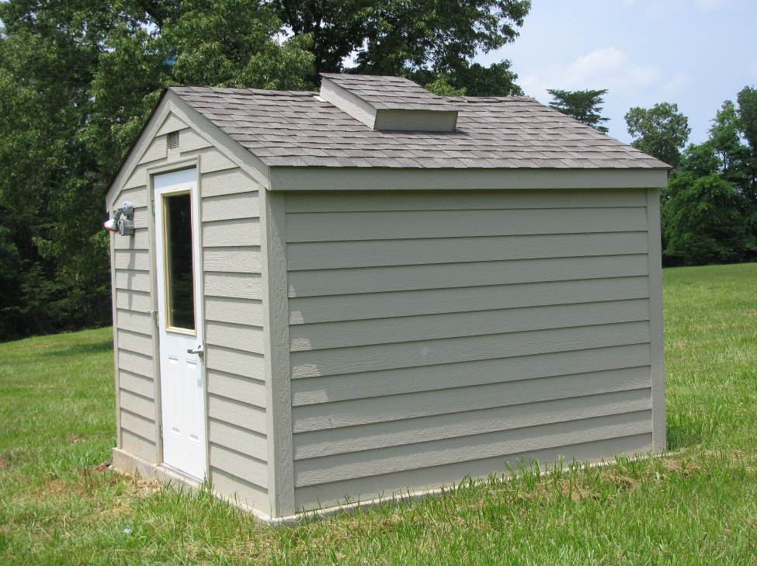
Photograph 3 – Contentment Island Well #2

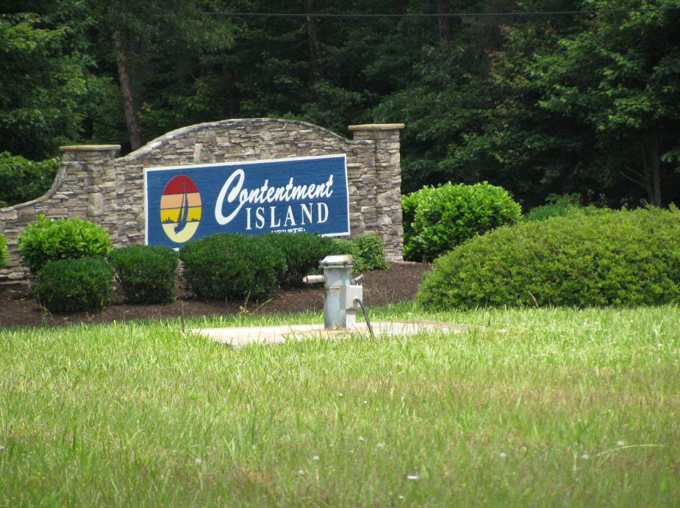

Photograph 4 – Contentment Island Well # 4

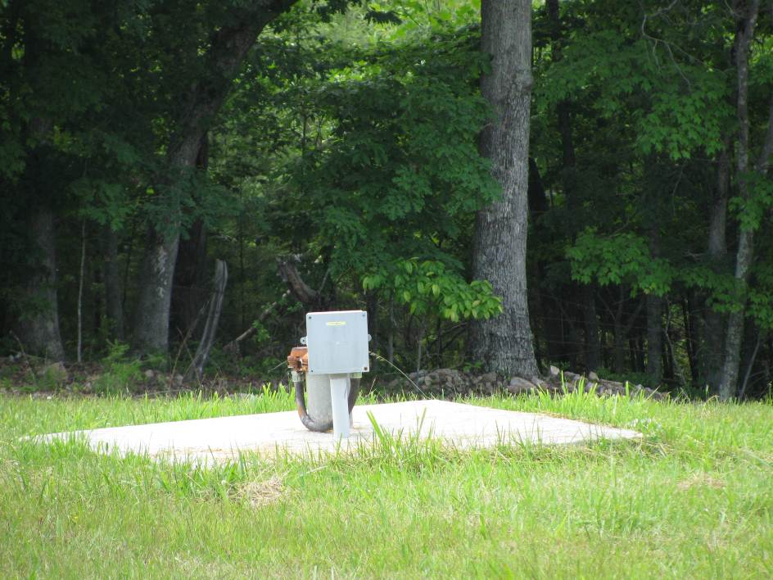

INVENTORY OF POTENTIAL SOURCES OF CONTAMINATION

Potential Sources of Contamination

Table 5 summarizes the land uses and potential sources of contamination for the wells at Contentment Island, that could pose a potential threat to the quality of source water to the wells. Figure 1, shows the location of the potential sources of contamination within the WHPA.

The primary potential sources of contamination to the WHPA are the private septic systems serving the homes within the Contentment Island WHPA. The septic tank for each home is located on the homeowner’s lot. Based on site observations and information obtained from the Franklin County GIS, it appears adjacent subdivisions are also utilizing private septic systems.

Additionally, other private and community wells, and residential uses of pesticides, fertilizers, chemicals, oil, etc may be potential sources of contamination that are the most likely to affect groundwater quality in the area.

Within the Zone 1 is another community system production well for the Land’s End Subdivision. This subdivision has 53 lots (only approximately 13 of these lots are within 1000-ft of one of the Contentment Island Wells) and a single community drain-field that services all the lots within this subdivisions. The records with VDH for the water system indicate there are 28 connections to the water system, so some of the 53 lots may not have been constructed yet or may be used for purposes other than a residential house (vacant lots, etc). The actual location of the community drainfield was not able to be determined, but it approximated on the map based on being within the common area of the subdivision where some trees were cleared during the subdivision construction. This approximate area is within 1000-ft of the Contentment Island Wells. Also within 1000-ft of the Contentment Island wells is the septic drainfield associated with the Contentment Island Pool clubhouse and the pool. In addition, there is one parking lot used for extra parking and boat storage. No other septic systems or private wells or potential sources of contamination appear to be within the Zone 1.

Table 5 - Land Uses of Concern and Potential Sources of Contamination
Land Uses/Potential Sources of Contamination | Potential Risk to GW/ | Type of  Contaminate | All Wells (#1-#4)
Within Zone 1 (1,000 ft radius)
On-Site Septic  Systems at  Nearby Subdivisions | Low | Biological | 1 (Contentment Island Pool/Club House)
Community  Drainfields | Moderate | Biological | 1 (28 connections)
Residential  Use of Fertilizers,  Pesticides, Chemicals, Petroleum, etc. | Low | Chemical | Continuous
Other Community Wells/Private Wells | Moderate/ | Unknown-potential  for entry of surface water into aquifer | 1 (Lands End PWSID #5067415)
Within Zone 2 (1 mile radius)
On-Site Septic  Systems at  Nearby Subdivisions | Low | Biological | Individual houses outside subdivisions: 76 drainfields  Contentment Island Subdivision: 111 Septic Systems  Highland Lake Subdivision: 118 Septic Systems  Pelican Point: 7 Septic Systems  Lakeside Water company: 11 Septic Systems  Highland Shores Subdivision: 2 Septic systems  Total Septic Systems within 1-mile – 325
Community  Drainfields | Low | Biological | Highland Shores Subdivision (Approximately 64 connections)  Lakeside Water Company (12 connections)  Highland Point Condominiums (Approximately 60 units)
Other Community Wells | Low | Unknown-potential  for entry of surface water into aquifer | Highland Lake (PWSID #5067086) – 2 Wells  Pelican Point – 1 well  Lakeside Water Company – 1 Well
Private Wells | Low | Unknown-potential  for entry of surface water into aquifer | 74
Commercial  Establishments | Low | Chemical | Pelican Point Yacht Club, Inc
Residential Use of Fertilizers, Pesticides, Chemicals, Petroleum, etc. | Low | chemical | Continuous
Note: Low, Moderate, and High Risk is determined by the proximity of the potential source of contamination to the monitoring well, whether the source is upgradient or downgradient of the well, and the likelihood of contamination occurring as well as the type of contamination that would occur.

Within Zone 2, there are several community drainfields, community wells, private wells, and private septic systems. There also is one commercial establishment that is a Yacht Club/Marina. According to their website, the facility does boat repair and maintenance, and has a bath house, and a pool. As long as this facility is following standard best management practices for fuel storage and chemical storage, the risk of groundwater contamination in the Contentment Island wells is low.

Identifying New Potential Sources of Contamination
The identification of existing contamination sources will help to address immediate concerns about protection of the local water supply. To ensure that the supply remains uncontaminated, continual review of land use activities and identification of potential sources of contamination is necessary. A summary listing of various sources of contamination that are commonly considered is included in Appendix B.

SUSCEPTABILITY ANALYSIS

The susceptibility analysis is a procedure for determining how the potential pollutant sources identified in the inventory pose a risk to the quality of the source water. The results of the Source Water Assessment Program are summarized in the following Table.
Table 3: Susceptibility Analysis Results
Source Name | Susceptibility to Contamination | Explanation
Well 1 | High | Ground water source constructed in an area that tends to promote migration of contaminants with land use activities of concern and potential conduits to ground water in the Zone 1 assessment area and potential sources of contamination in Zone 1 or Zone 2 assessment areas.
Well 2 | High | Ground water source constructed in an area that tends to promote migration of contaminants with land use activities of concern and potential conduits to ground water in the Zone 1 assessment area and potential sources of contamination in Zone 1 or Zone 2 assessment areas.
Well 3 | High | Ground water source constructed in an area that tends to promote migration of contaminants with land use activities of concern and potential conduits to ground water in the Zone 1 assessment area and potential sources of contamination in Zone 1 or Zone 2 assessment areas.
Well 4 | High | Ground water source constructed in an area that tends to promote migration of contaminants with land use activities of concern and potential conduits to ground water in the Zone 1 assessment area and potential sources of contamination in Zone 1 or Zone 2 assessment areas.

Wellhead Protection Plan
The Source Water Protection Plan describes the actions necessary to minimize the risk to the quality of the source water utilized by the Contentment Island water system. The goal of the plan is to reduce or eliminate potential threats to drinking water supplies within WHPAs either through existing regulatory or statutory controls, or by using non-regulatory (and often voluntary) measures centered around an involved public.

Measures in Place
Current measures in place for protecting the quality of water within the wellhead protection area are:
- Annual water testing;
- Routine maintenance of the water system;
- Surrounding land is well vegetated which minimizes risk of runoff;
- According to the Franklin County Comprehensive Plan, drainfields of all types must be 100-feet from a public water system’s wells and septic tanks must be 50-feet from public water system’s wells. The required distances may be varied depending on slopes in an area and the degree of well protection provided;
- The County code (Sec. 17-8 Mandatory Septic Tank Pump-out) requires septic tanks or drain fields that are located within five hundred (500) feet of the seven hundred ninety-five-foot contour of the shores of Smith Mountain Lake to be pumped out at least once every five (5) years;
- Franklin County’s Erosion and Sediment Control Ordinance (Section 7 of the County Code) serves to minimize the negative impacts to water resources resulting from land disturbances associated with new development. The ordinance requires that certain erosion and sediment control measures be implemented as part of the development process.

The Contentment Island Subdivision wells are located in Franklin County’s Single Family Residential (R-1) Zoning District. The R-1 designation permits the following uses by right: Accessory uses; churches; conservation areas (public and private; garages (private for storage of personal vehicles); gardens (private); horses; manses (church-owned dwelling unit); private dock, pier, and boathouse; playgrounds (public); off-street parking; roads, streets, rights-of-way, easements; signs; single-family detached dwellings; subdivision (meeting the county subdivision ordinance); temporary construction facilities; water systems (Franklin County, 1988). The nature of uses permitted by R-1 zoning is consistent with groundwater protection.

Public Education
For citizens to appreciate the benefits of source water/wellhead protection, they must first understand what the problems are in providing safe drinking water, and how they can become involved in the process. Examples of public education include brochures, pamphlets, field days, mall displays, town meetings, and other mass-exposure opportunities to present wellhead protection problems and protection efforts to the public in a straightforward, understandable fashion. Public education is the most effective tool to promote voluntary action and public support for a community’s wellhead protection program.

A number of specific actions directed at public education are included in the recommendations in the next section. These should be considered as a starting point. Other activities and opportunities should be sought to increase public awareness of groundwater protection is a local issue, and to understand that each citizen plays a part.

Recommended Actions
- Promote general Wellhead Protection education for the residents within the Wellhead Protection Area.
- Brochures designed specifically for the waterworks that address the following concerns: (1) a general overview of the importance of wellhead protection; (2) the local nature of groundwater recharge – what you do matters; (3) concerns with local geology; and (4) a list of general dos and don’ts. An example brochure is included in Appendix C.
- Brochures or information on safe management of pesticides and fertilizers in your home (such as “Better Backyard” available from the Chesapeake Bay program at: http://www.chesapeakebay.net/content/publications/cbp_12259.pdf).
- Attach wellhead protection articles to water bills or subdivision POA or community newsletter, if applicable. Examples of wellhead protection articles are provided in Appendix C.
- Pair Wellhead Protection Information with Cross Connection Control Surveys that includes information about potential sources of contamination. An example survey is included in Appendix C.
  - Develop business cards to hand out to residents with questions about wellhead protection. An example business card is provided in Appendix C.
  - Mail the Communities’ Wellhead Protection brochure to each residence in the WHPA (Zone 2). Septic system informational brochures will be included in the mailing to those homes that may have a septic system.
  - Hold an annual meeting between the Contentment Island water operators and the Property Owner’s Association members to discuss wellhead protection information and activities in the community.
  - To increase local visibility and awareness of the WHPA, install signs along roads in high-visibility locations near to the designated boundary of the wellhead protection area that state “Entering Wellhead Protection Area”.
  - Annually review the designated WHPA zone and appropriate response procedures with pertinent emergency response personnel. Provide an emergency information sheet that shows the WHPA, roads, and emergency contact information. An example is provided in Appendix D.
  - Annually review and update the WHPP.
  - Identify and update list of PSCs.
  - Review educational program.
  - Assess progress on achieving the WHPP goals.

REFERENCES

Bailey, C.M. 1999. “Simplified Geologic Map of Virginia”

Franklin County Board of Supervisors. 2007. Franklin County 2025 Comprehensive Plan.
http://www.franklincountyva.gov/planning-comm/resources/fc-2025-comp-plan

Franklin County, Virginia. Code of Ordinances; Chapter 25: Zoning.
http://library.municode.com/index.aspx?clientID=10799&stateID=46&statename=Virginia

Henika, W.S., 1997, Geologic map of the Roanoke 30 x 60 minute quadrangle: Virginia Division of Mineral Resources, Publication 148, scale 1:100000.
http://ngmdb.usgs.gov/ngm-bin/ILView.pl?sid=39853_1.sid&vtype=b

Unites States Department of Agriculture (USDA) Natural Resource Conservation Service (NRCS). “Web Soil Survey” http://websoilsurvey.nrcs.usda.gov/app/WebSoilSurvey.aspx

United States Geological Survey for Virginia Department of Environmental Quality. 2009. Low Flow and Base Flow Characteristics for Streams in Virginia. http://va.water.usgs.gov/vadeq_data/citycount_scroll.htm. Accessed February 2012.

Virginia Department of Health. 2009 Annual Quality Drinking Water Report: Contentment Island..

Virginia Department of Health. 2010. Engineering Description Sheet: Contentment Island.

Virginia Water Resources Research Center (VWRRC). 1999, Reprinted. “A Guide to Virginia’s Ground Water”

