‘N’ drive folder nothing in it check m&p 

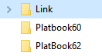

Confirm:



 move to Bot./Daleville & m&p updated

 move to Bot. (Fincastle?) & m&p updated

 move to Bot./Daleville & m&p updated

 move to Bot./Daleville & m&p updated move to Bot./Daleville & m&p updated

Clear up names

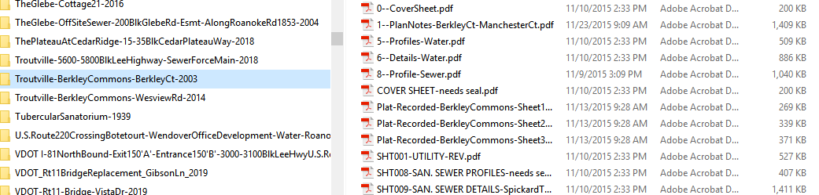

Take out extra space, updated m&p:

Bridges:

Byron are plats. Move & update m&p