04/22/2020 .tiffs to convert to .pdf in ‘v’dr, if project is in ‘n’ drive, delete ‘v’ drive when done

‘V’/KIP/Nora

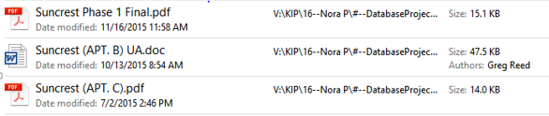

??(same project)

Fralin & Waldron Office Park

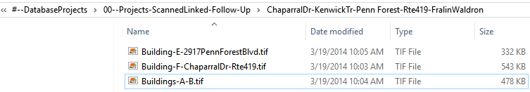

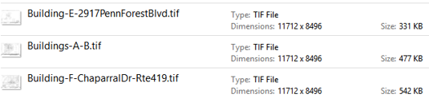

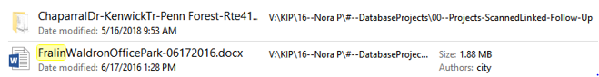

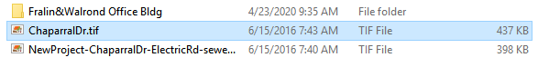

‘N’ drive/FralinWaldron



GIS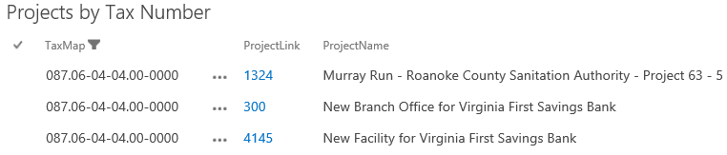

check title for Fralin Waldron 

Complete:‘N’ drive-Survey for Fralin Waldron

‘V’ drive

