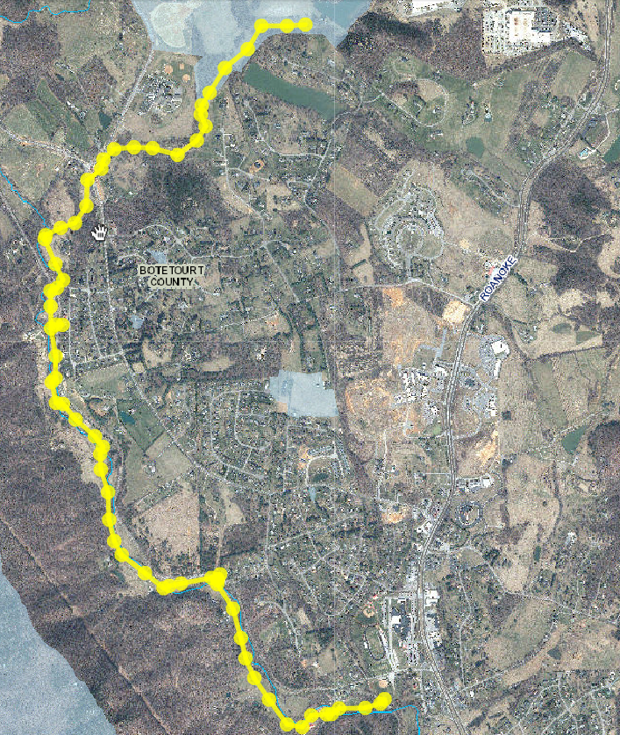

AERIAL SHOWING THIS PROJECT: 05/16/2018

GREENFIELD COLLECTOR AND TINKER CREEK EXTENSION

BOTETOURT COUNTY AS-BUILT: 12/01/1996

TINKER

CREEK

TINKER MILL RD

BOTETOURT CENTER AT GREENFIELD

ORCHARD LAKE DR

CATAWBA ROAD