BOTETOURT CENTER AT GREENFIELD (COPY PASTE ON 24” X 36” – SCAN/ADD TO PROJECT AS A WHOLE) FIND ANY PLATS FOR UTILITIES OR PLANS AS INFRASTRUCTURE VIA BOTETOURT COUNTY

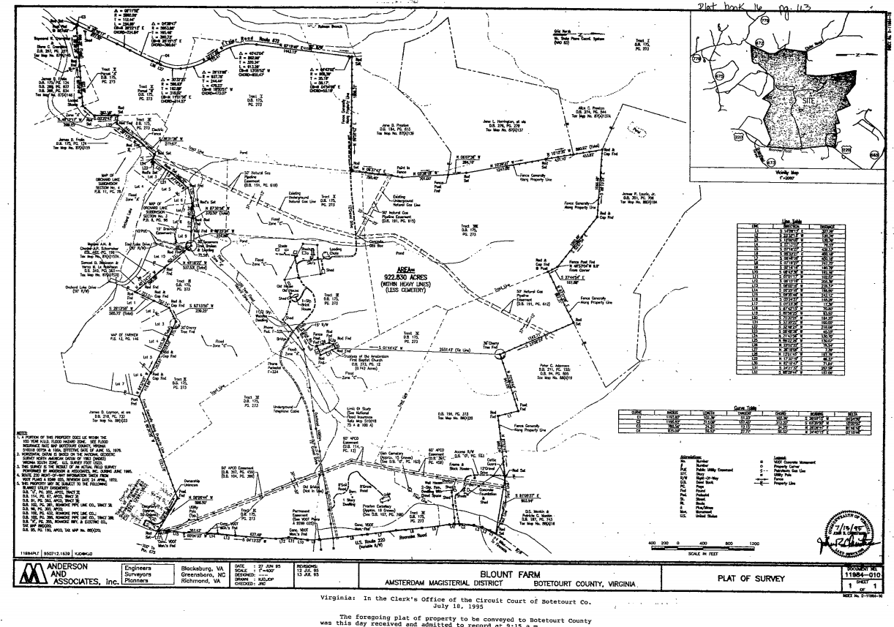 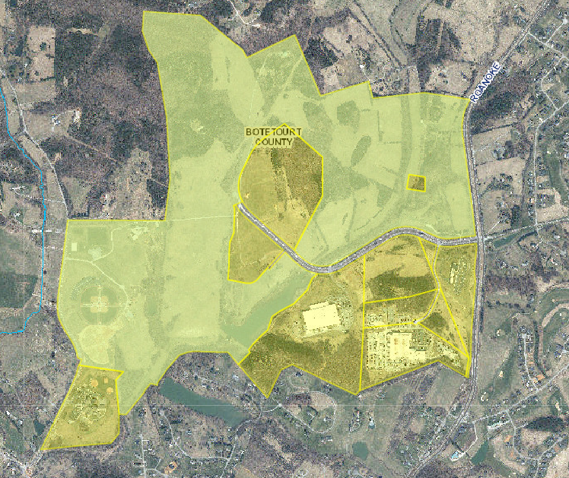 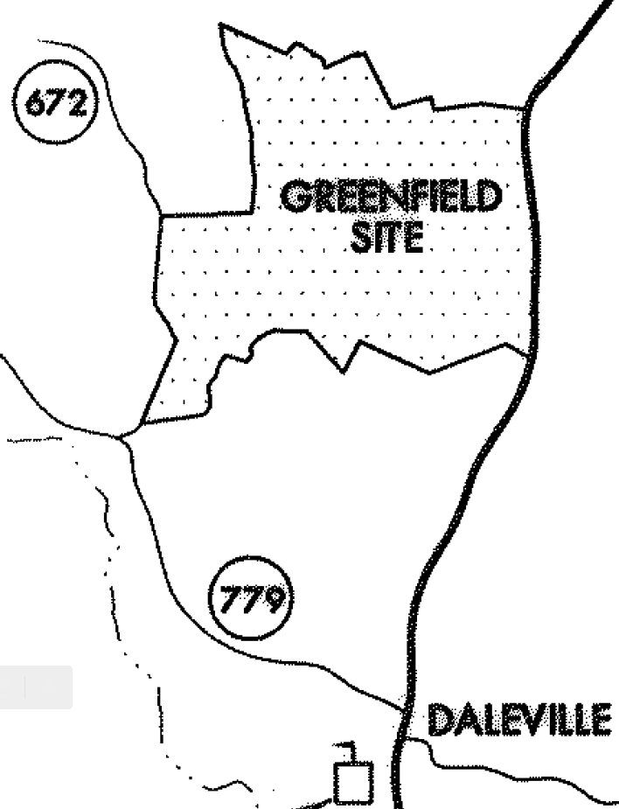 **672**-Etzler Rd **779**-Catawba Rd 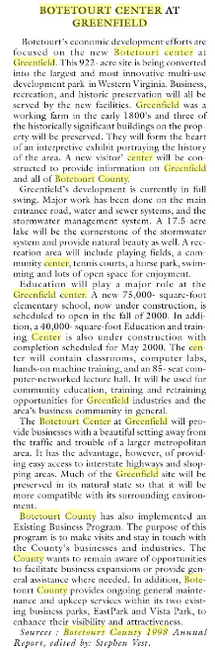

Botetourt Center at Greenfield

From article above: “In **1995**, Botetourt County purchased a 925-acre tract of land along the west side of Route 220 to develop the Botetourt Center at Greenfield as a mixed-use industrial and business complex. The development would also include a recreation area, an elementary school, and an educational/training center.”

P.B. 16 PG 113 - 'The plat of property, (Blount Farm) was conveyed to Botetourt County July 18, 1995.' 'The property had 922.830 Acres (less cemetery).' 'See Plat of Survey - PlatBook 16 PG.63.' This property is now Botetourt Center at Greenfield, assigned T# 88-20 and addressed 160 Preston Parkway.’ 'International Pkwy and Va Route 839 are one and the same.' 'Etzler Rd and Va Route 672 are one and the same.' 'Preston Pkwy and Va Route 825 are one and the same.' 'Roanoke Rd and U.S. Route 220 are one and the same in this area.' 'South Center Dr and Va Route 843 are one and the same.'

Since this plat (P.B. 16 PG 113), the property has been subdivided. As of 06/26/2015 (date of this note), the following parcels have been created:

T# 87-148 - Greenfield Elementary School - 288 Etzler Rd

T# 88-20 - Botetourt Sports Complex, Greenfield Recreation Park, and rest of the original acreage - 160 Preston Pkwy

T# 88-20A - The Industrial Development Authority of Botetourt - Greenfield Education and Training Center - 57 South Center Dr

T# 88-20B - LARE, Inc - (initial facility was Koyo Steering Systems of USA, Inc) 555 International Pkwy

T# 88-20C - Altec Industries, Inc - 0 South Center Dr

T# 88-20C1 - Altec Industries, Inc - 325 South Center DrT# 88-20C2 - Botetourt County - 0 South Center DrT# 88-20D - Botetourt County - no street reference

T# 88-20E - Cemetery - Trustees of the Amsterdam First Baptist Church

T# 88-20F - Appalachian Power Company

Etzler Rd & Va Route 672 are one and the same.

International Pkwy & Va Route 839 are one and the same.

Preston Pkwy & Va Route 825 are one and the same.

Roanoke Rd & U.S. Route 220 are one and the same in this area.

South Center Dr & Va Route 843 are one and the same.

Date: 1995-Current

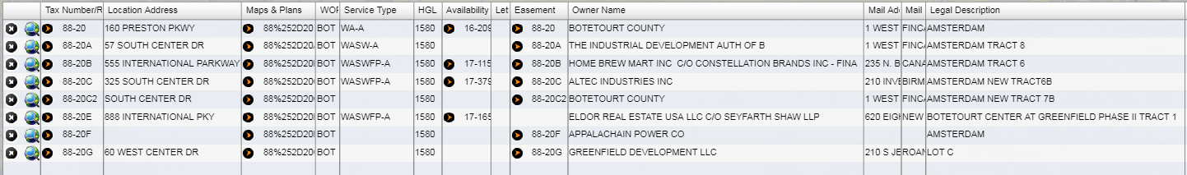

OWNERS:

BOTETOURT COUNTY

THE INDUSTRIAL DEVELOPMENT AUTHORITY OF BOTETOURT

GREENFIELD DEVELOPMENT LLC

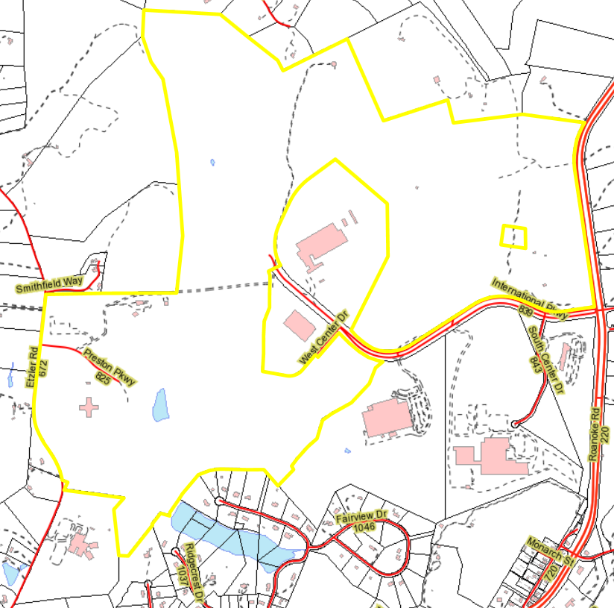

THE INDUSTRIAL DEVELOPMENT AUTH OF BOTETOURT

57 SOUTH CENTER DR

88-20A

AMSTERDAM TRACT 8

03/29/1999 (NO COMPANY NAME FOR TRANSFER OF OWNERSHEIP

GREENFIELD DEVELOPMENT LLC

60 WEST CENTER DR

88-20G

LOT D

BOTETOURT COUNTY TO ECONOMIC DEVELOPMENT AUTHORITY OF BOTETOURT: 08/04/2016

ECONOMIC DEVELOPMENT AUTHORITY OF BOTETOURT TO GREENFIELD DEVELOPMENT LLC: 08/08/2016

ELDOR REAL ESTATE USA LLC

888 INTERNATIONAL PKWY

88-20E

BOTETOURT CENTER AT GREENFIELD PHASE II TRACT 1

BOTETOURT CO. TO ELDOR: 03/24/2017