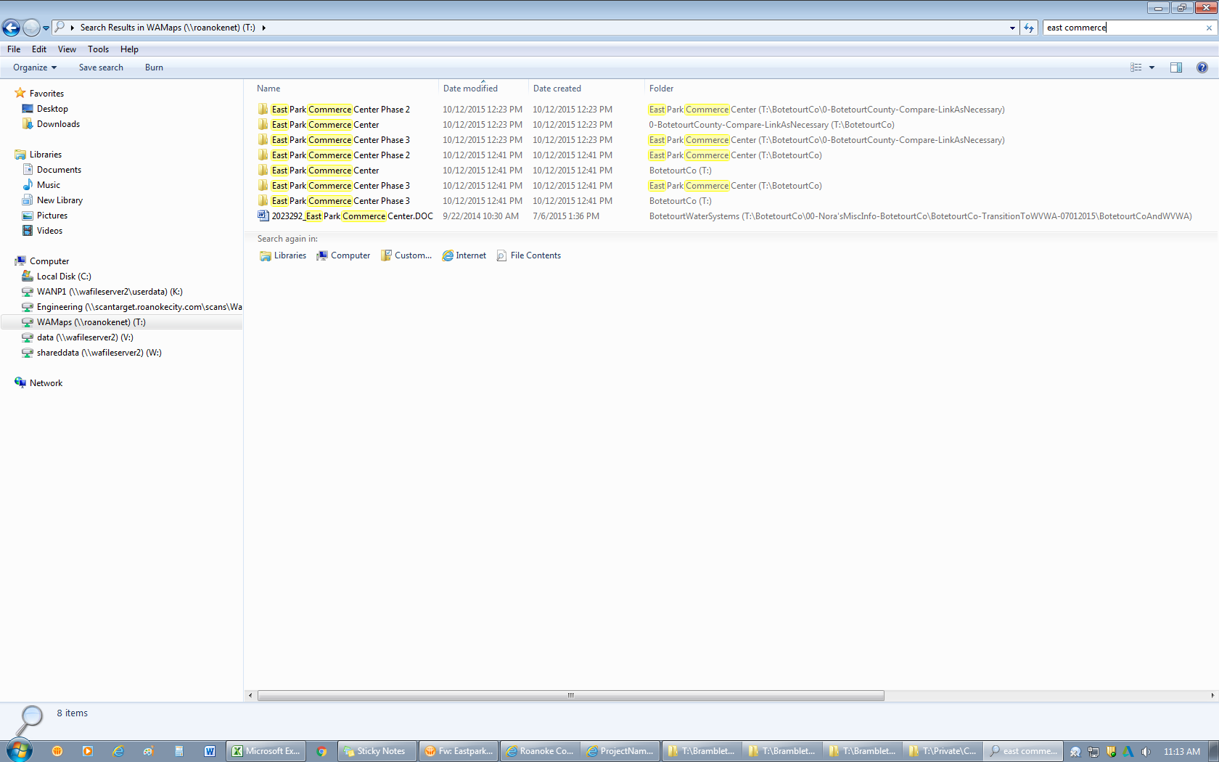

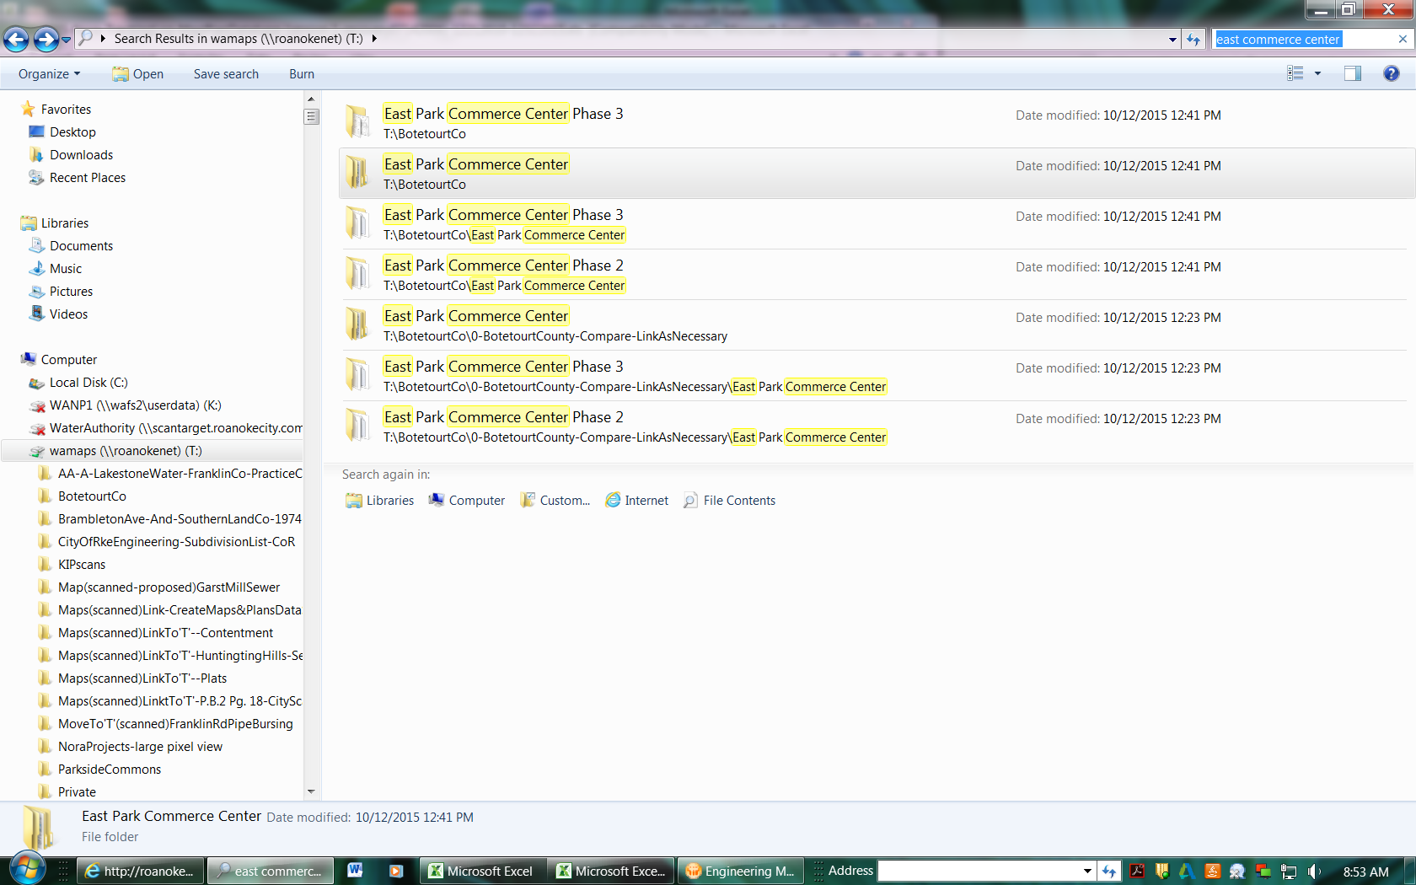

|  |
| --- |
| 108(13)1 |
| 108(13)2A |
| 108(13)3 |
| 108(13)4 |
| 108(13)5 |
| 108(13)5A |
| 108(13)6 |
| 108(13)8 |
| 108(13)9 |
| 108(13)9A |
| 108(13)9B |
| 108(13)10A |
| 108-140C |