VDOT – Cotton Hill Rd widening and water line relocation (working to link with m&p and GIS

Tax # 096.07-12-07.00-0000 Instrument # 2014- State Highway Plat Book 17 PG

6024 Matisse Ln

Tax # 096.07-12-06.00-0000 Instrument # 2014- State Highway Plat Book 17 PG

6020 Matisse Ln

Tax # 096.07-12-05.00-0000 Instrument # 2014-09071 State Highway Plat Book 17 PG329

6016 Matisse Ln

096.07-12-26.00-0000

Tax # 096.07-12-04.00-0000 Instrument # 2014-10159 State Highway Plat Book 17 PG334

6012 Matisse Ln

096.07-12-25.00-0000

096.07-12-08.00-0000

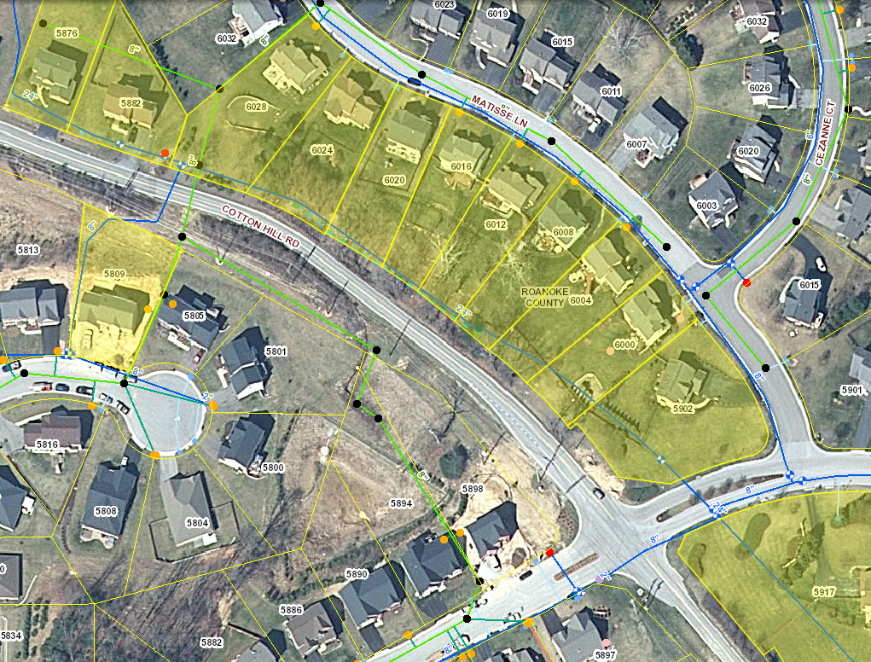

096.07-03-01.00-0000

096.07-15-23.00-0000

096.07-12-01.00-0000

096.07-11-01.00-0000

096.07-12-02.00-0000

096.07-12-03.00-0000

096.07-12-04.00-0000

096.07-12-05.00-0000

096.07-12-06.00-0000

096.07-12-07.00-0000

Tax # 096.07-12-05.00-0000 Instrument # State Highway Plat Book 17 PGs 5 6016 Matisse Ln

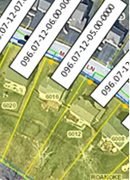 Tax # 096.07-12-04.00-0000 Instrument # 2014-10159 State Highway Plat Book 17 PGs 334-335 6012 Matisse Ln

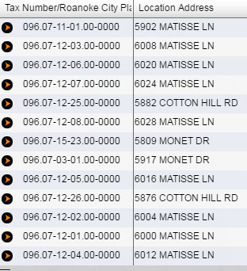 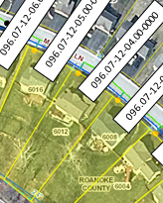

Tax # 096.01-03-02.00-0000 Instrument # 2014-09072

