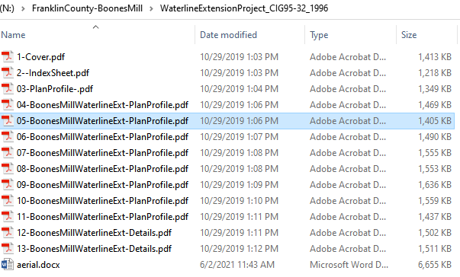

03-

04-

05-Leaning Oak Rd-Bethlehem Rd

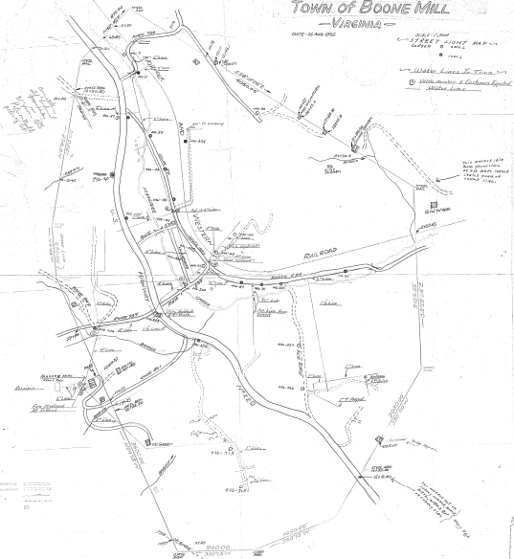

4782 Interconnect 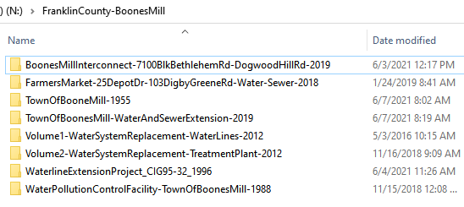

4635 Water CIG95-32

4572 Water, Sewer,-Field Locations

4510 Water Pollution Control Plant

4508 Town of Boones Mill Digby Greene Rd

4508 Farmer’s Market Water & Sewer

3493 Water – Volume !

3489 Water – Volume 2