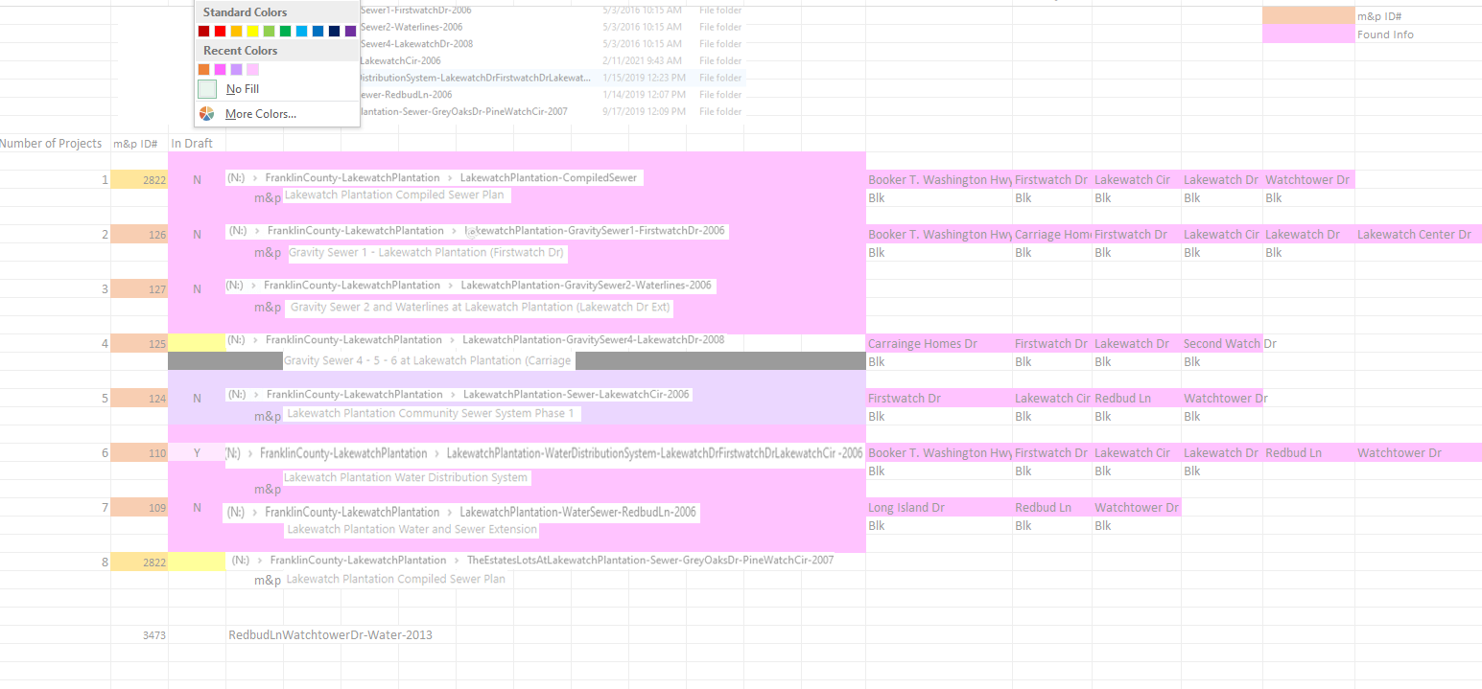

109

124



125

127

N drive

Gravity Sewer 2 and Waterlines at Lakewatch Plantation (Lakewatch Dr Ext) m&P name

2822

3473

**ID# 110 in m&p ‘Draft’**

