Nora, here is the complete list I was given at the end of last year.(2015) (Erika sent me 02/22/2016)

Franklin County

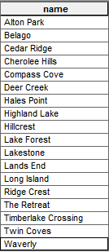

------------------------------------------------------------------------------------------------------------------------------------------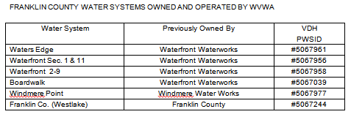

10/01/2010 – WVWA acquired Contentment Island