In 2 locations – combine & delete (N:) FranklinCounty-LongIslandEstates and any other drive

Delete 1 & Update m&p in both places

**‘K’ drive - NO MORE LONG ISLAND PROJECTS HERE 12/05/2018**

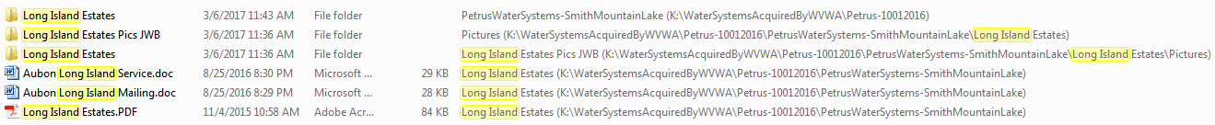

**-------------------------------------------------------------------------------------------------------------------------------------------------------------------------------------------------------------------**

’N’ drive

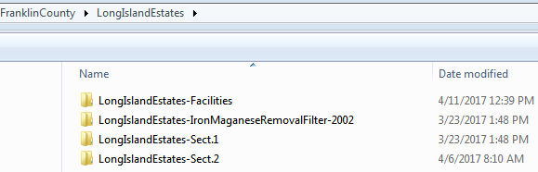



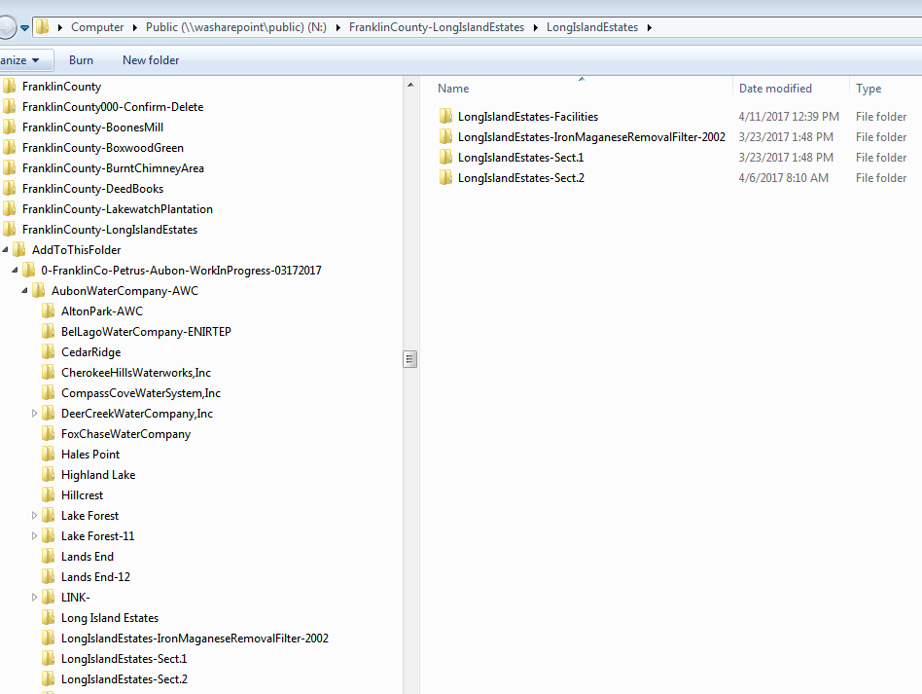

‘N’ drive continued

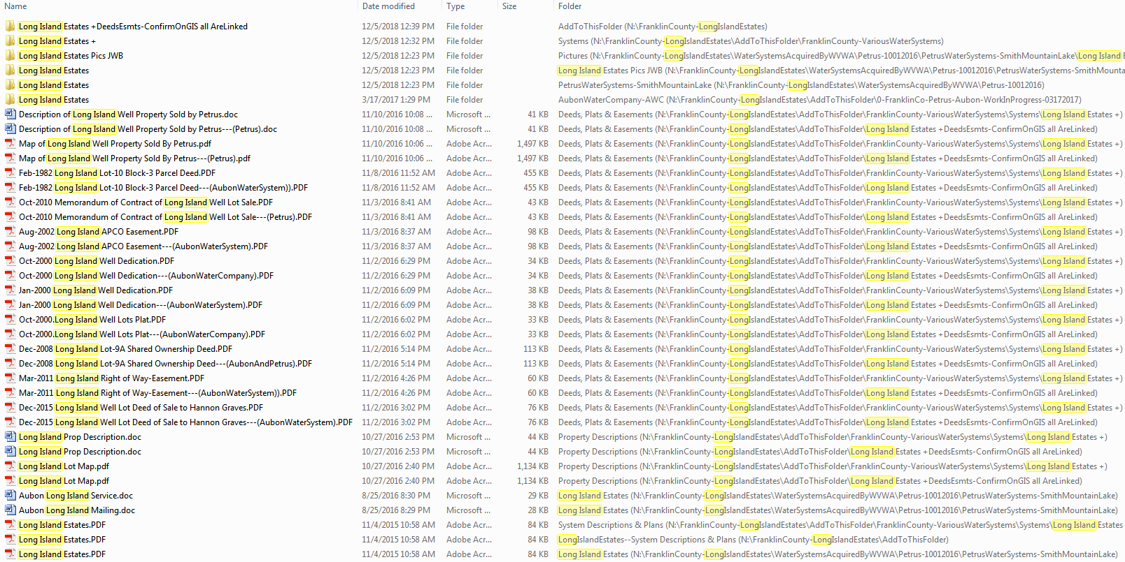

**----------------------------------------------------------------------------------------------------------------------------------------------------------------------**-------------------------------------------------

‘V’ drive

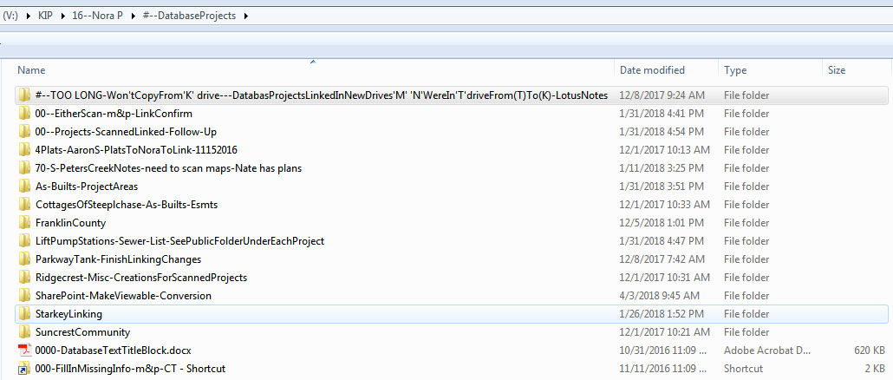

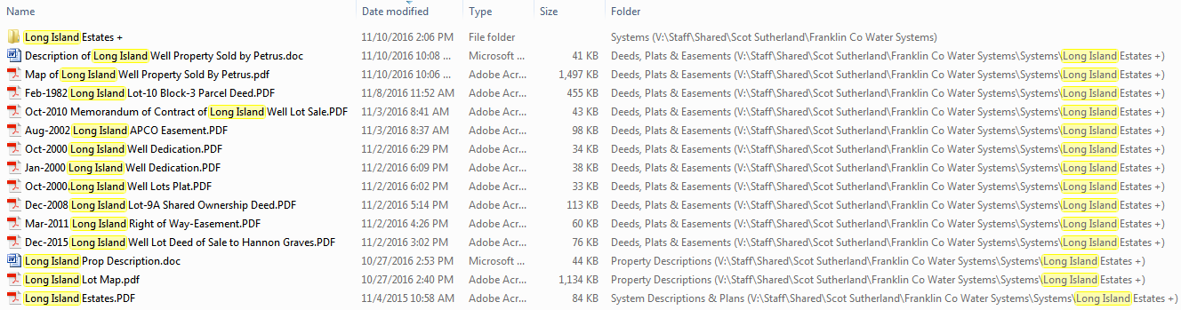

‘V’ drive continued

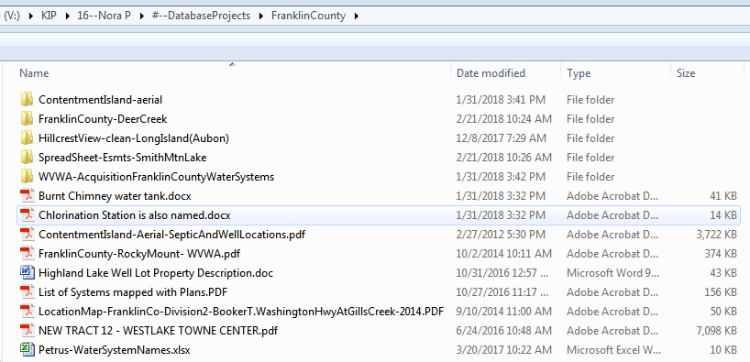

**----------------------------------------------------------------------------------------------------------------------------------------------------------------------------------------------------------------------------**

‘W’drive – snipped & copied - related to Long Island – confirm if needed or linked

