Lakewood & Weatherwood Interconnection 2020

Well Lots, Wells, Tanks, Pump Stations

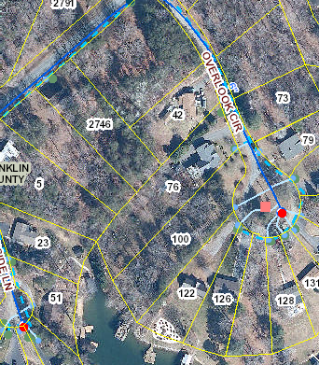 Sheet 26 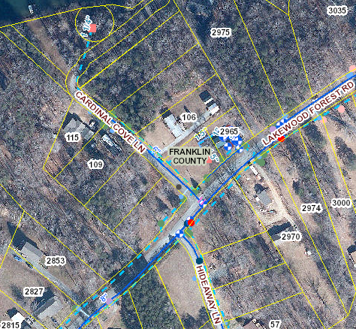 Sheet 28

Lakewood Forest Well #2 T# 0310100603 Lakewood Forest Well Lot Well #3

Overlook Cir cul-de-sac part of Lot 88

Cardinal Cove Ln, northwest of Lakewood Forest Rd

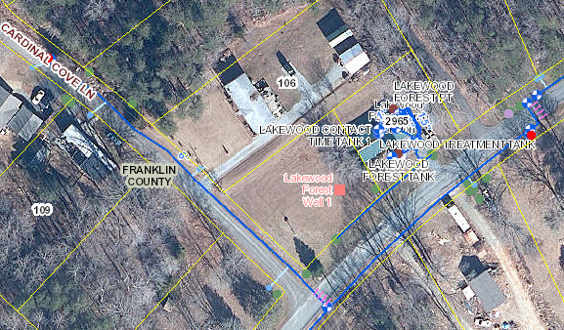 Sheets 21 and 28

T# 0310100200 Lakewood Forest Well Lot

T# 03100100100 Lakewood Forest Well #1 2965 Lakewood Forest Rd Lot 84

Lot 89 northeast intersection of Lakewood Forest Rd

and Cardinal Cove Ln

Lakewood Forest Tank

Lakewood Treatment Tank

Lakewood Contact Time Tank #1

Lakewood Contact Time Tank #2

Lakewood Forest Pump Station

Lakewood Forest PT

T# 0310601500

Weatherwood Well Lot,

Weatherwood Well #3

northeast intersection of Lakewood Forest Rd and Chickadee Cir.

T# 0310601800

Weatherwood Well #1

and Weatherwood Well #2

west side of Goldfinch Cir

Weatherwood Lot 17

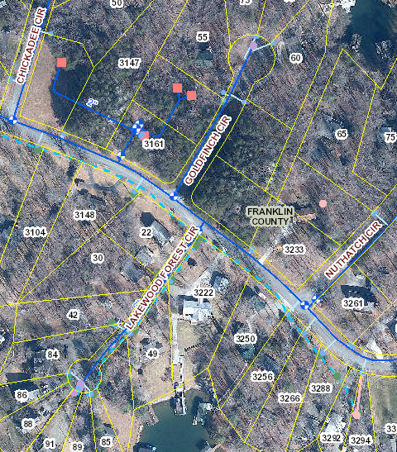 Sheets22 and 23

T# 0310601700

Weatherwood Pump Station

and Weatherwood Well #4

3161 Lakewood Forest Rd,

Weatherwood Lot 16