Need

C-003

C-101

C-105

C-106

C-201

C-501

C-502

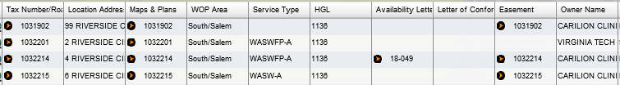

Commerical meter vault 6" fire, 3" domestic water , 2 - sewer connections, relocation of 12" main (water) and a hydrant.

