**Summit—A-2 Revision text**



**Summit—A-1** **add Revised July 28, 1986**

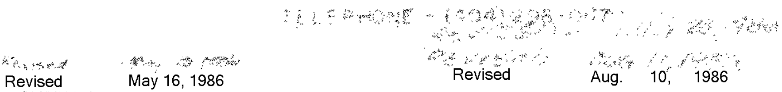

Summit—A-1-LINE-2-3-3

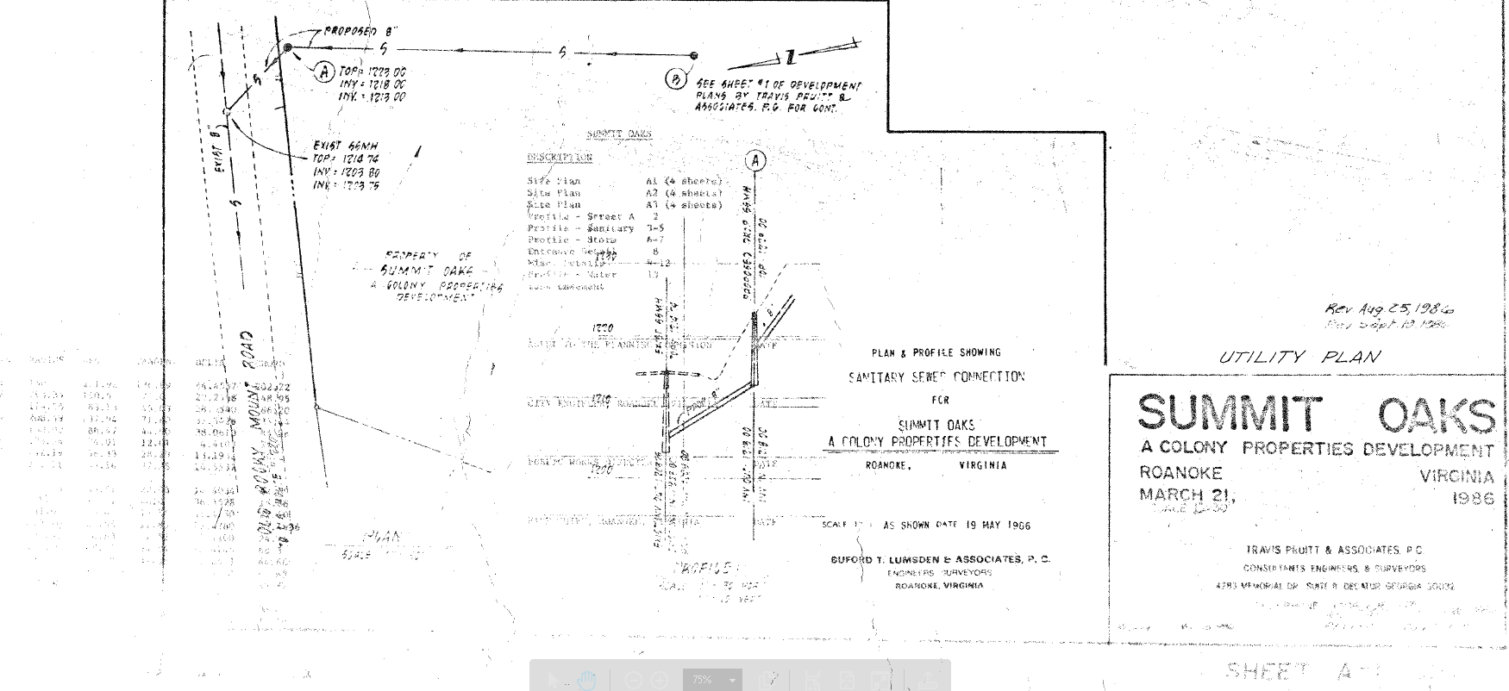

NO-SummitOaks—A-1-Plan-Utility-200dpi-5thresh-3Sharp

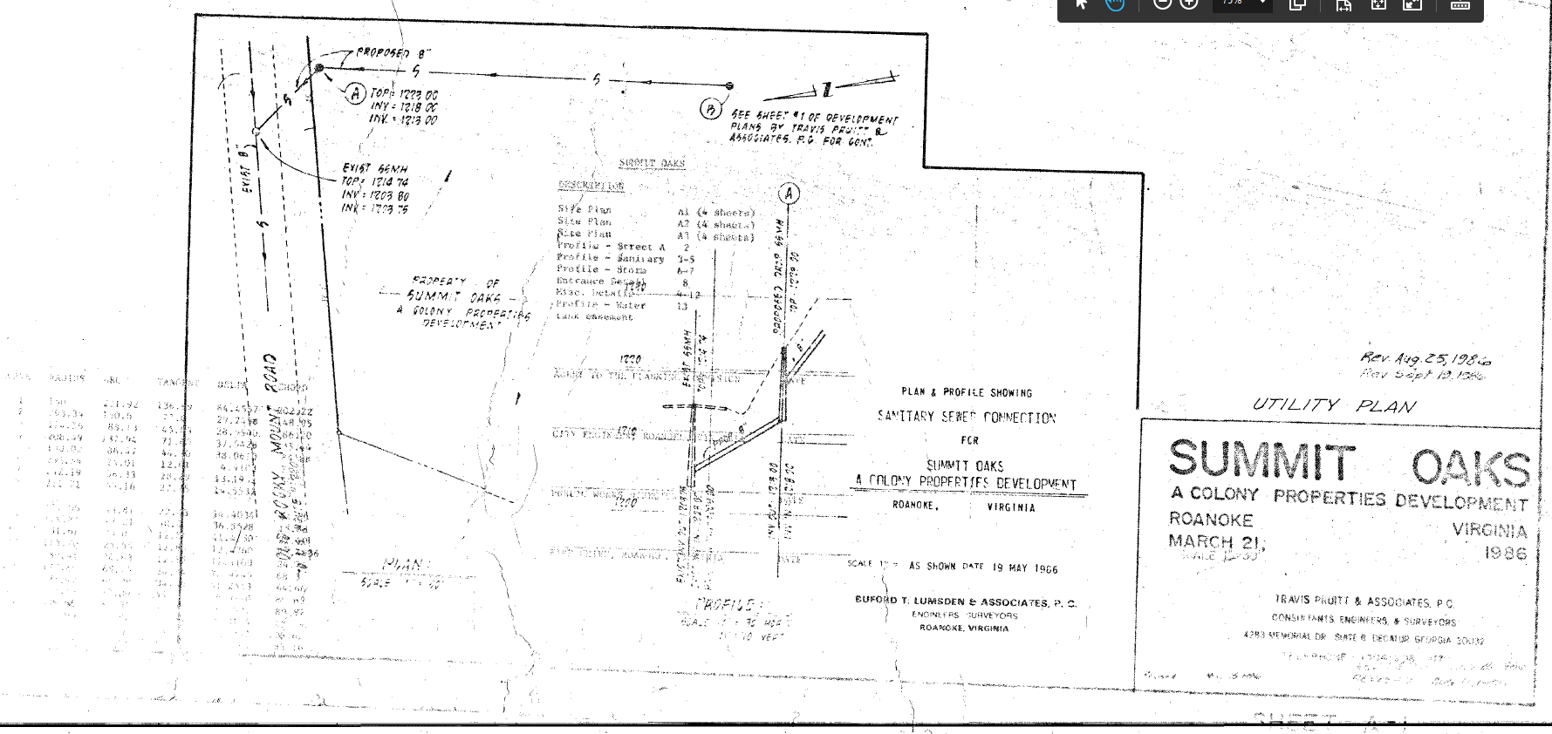

Summit—A-1-LINE-2-6-4

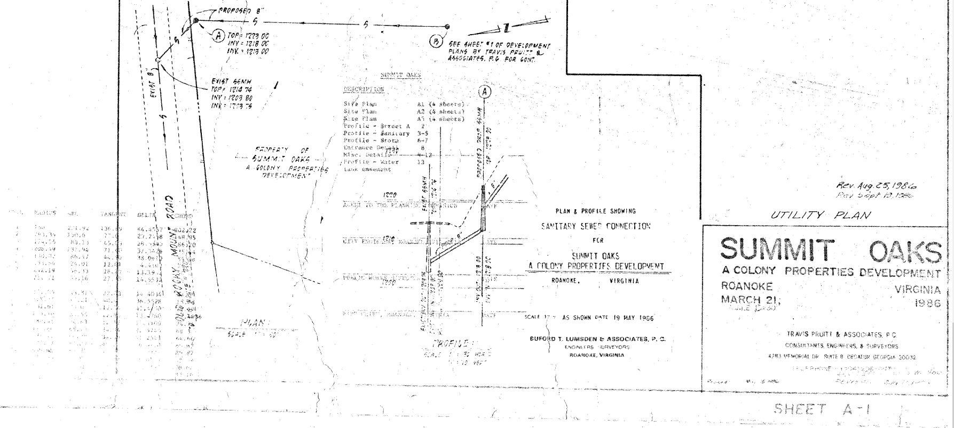

No-SummitOaks---A-1-Plan-Utility-300dpi-7thresh-4sharp

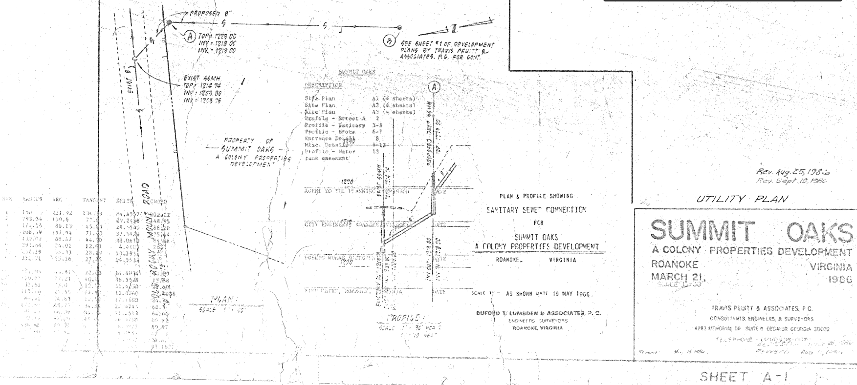

NO-SummitOaks—A-1-Plan-Utility-300dpi-8thresh-4sharp

