03/06/2018 Tanglewood Mall Area

04/09/2018 complete everything w/Tanglewood/Ore Branch

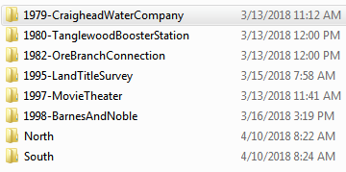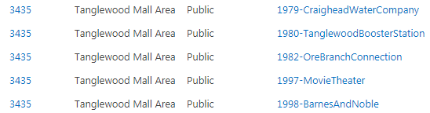

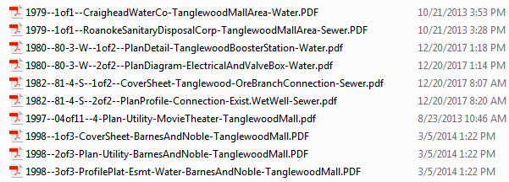

 

RkeCo # 



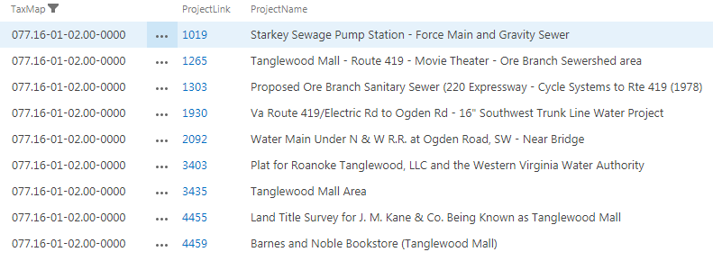

|  |  |  |  |  |  |  |  |
| --- | --- | --- | --- | --- | --- | --- | --- |
| T/R | 12/20/2017 | 3435 | Tangelwood Mall area - 1979 - Rke Sanitary Disposal Corp | 03/13/2018 |  |  | |
| 514-T/R | 12/20/2017 | 1265 | Tangelwood Mall area - 1997 - Movie Theater utilities |  | N' drive complete - update m&p | |
| 515-T/R | 12/20/2017 | 3435 | Tangelwood Mall area - 1997 - Movie Theater utilities | 03/13/2018 | N' drive complete - update m&p | |
| 516-T/R | 12/20/2017 | 3435 | Tangelwood Mall area - 1998 - Barnes and Noble | 03/13/2018 | N' drive complete - update m&p | |
| 517-T/R | 12/20/2017 | 4459 | Tangelwood Mall area - 1998 - Barnes and Noble | 03/13/2018 | N' drive complete - update m&p | |
| 518-T/K | 12/20/2017 | 3435 | Tangelwood Mall area - 80-3-W | 03/13/2018 | N' drive complete - update m&p | |
| 638 - T/R | 03/06/2018 | 3403 | Plat for Roanoke Tanglewood, LLC and the Western Virginia Water Authority | 03/06/2018 | not viewing - updated m&p | |
| T | 06/24/2013 | 3403 | Plat for Roanoke Tanglewood, LLC and the Western Virginia Water Authority | 06/24/2013 | 1 page scanned | |
| T | 12/27/2017 | 4457 | plat - Division of property of Tanglewood Mall, Inc (Penn Forest Blvd, Bernard Dr, Electric Rd, Starkey Rd) P.B. 9 PG.180 | 03/14/2018 | previously scanned - create m&p | |
| T/K | 12/20/2017 | 3435 | Tangelwood Mall area - 80-3-W | 03/13/2018 | N' drive complete - update m&p | |
| T/O/R | 03/14/2018 | 1301 | Ore Branch Extension - Project No. 82-1-S (Route 220 from Route 419 to Crossbow Circle) | 03/15/2018 | previously scanned - updated m&p | |
| T/O/R | 03/14/2018 | 1775 | Ore Branch Sanitary Sewer Lower Segment - Wiley Dr to Cycle Systems - 1982 | 03/14/2018 | previously scanned - updated m&p | |
| T/O/R | 03/14/2018 | 1302 | Ore Branch Sanitary Sewer Upper Segment - Southern Hills Dr to Welcome Valley Rd - 1982 | 03/14/2018 | previously scanned - updated m&p | |
| T/O/R | 03/14/2018 | 1303 | Proposed Ore Branch Sanitary Sewer - 220 Expressway-Cycle Systems to Rte 419 (1978) | 03/14/2018 | previously scanned - updated m&p | |
| T/R | 10/11/2016 | 4455 | Tanglewood Mall Area - 1995-Land Title Survey for J. M. Kane & Co. to be known as Tanglewood Mall | 03/14/2018 | 3 pages -e-mail-- digital tif images - converted to pdf and updated m&p | |
| T/R | 12/20/2017 | 3435 | Tangelwood Mall area - 1979 - Rke Sanitary Disposal Corp | 03/13/2018 |  | |
| T/R | 12/20/2017 | 3435 | Tangelwood Mall area - 1979 - sewer and water | 03/13/2018 | N' drive complete - update m&p | |
| T/R | 12/20/2017 | 3435 | Tangelwood Mall area - 1982--81-4-S-1982 | 03/13/2018 | N' drive complete - update m&p | |
| T/R | 12/20/2017 | 1265 | Tangelwood Mall area - 1997 - Movie Theater utilities |  | N' drive complete - update m&p | |
| T/R | 12/20/2017 | 3435 | Tangelwood Mall area - 1997 - Movie Theater utilities | 03/13/2018 | N' drive complete - update m&p | |
| T/R | 12/20/2017 | 3435 | Tangelwood Mall area - 1998 - Barnes and Noble | 03/13/2018 | N' drive complete - update m&p | |
| T/R | 12/20/2017 | 4459 | Tangelwood Mall area - 1998 - Barnes and Noble | 03/13/2018 | N' drive complete - update m&p | |
| T/R | 03/06/2018 | 3403 | Plat for Roanoke Tanglewood, LLC and the Western Virginia Water Authority | 03/06/2018 | not viewing - updated m&p | |
| T/R | 03/15/2018 | 4459 | Barnes and Noble Bookstore - Tanglewood Mall | 03/16/2018 | previously copied from Roanoke County - create m&p | |
| T/R | 03/15/2018 | 1019 | Starkey Sewage Pump Station - Force Main and Gravity Sewer | 03/15/2018 | previously scanned - updated m&p | |
| T/R | 03/15/2018 | 1930 | Va Route 419/Electric Rd to Ogden Rd - 16" Southwest Trunk Line Water Project | 03/15/2018 | previously scanned - updated m&p | |
| T/R | 12/20/2017 | 3435 | Tangelwood Mall area - 1979 - sewer and water | 03/13/2018 | N' drive complete - update m&p | |
| T/R | 12/20/2017 | 3435 | Tangelwood Mall area - 1982--81-4-S-1982 | 03/13/2018 | N' drive complete - update m&p | |
| 10-T | 06/24/2013 | 3403 | Plat for Roanoke Tanglewood, LLC and the Western Virginia Water Authority | 06/24/2013 | 1 page scanned | |
| 48-T/R | 10/11/2016 | 4455 | Tanglewood Mall Area - 1995-Land Title Survey for J. M. Kane & Co. to be known as Tanglewood Mall | 03/14/2018 | 3 pages -e-mail-- digital tif images - converted to pdf and updated m&p | |
|  |  |  |  |  |  | |

 

Deleted this 2nd entry

-------------------------------------------------------------------------------------------------------------------------------------------------------------------------------------------------------------------------------------------

not viewing straighten out update m&p done

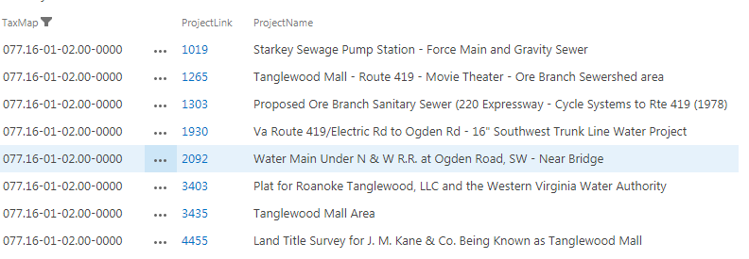

 find full project & put under ‘Ore Branch’

ID #1930

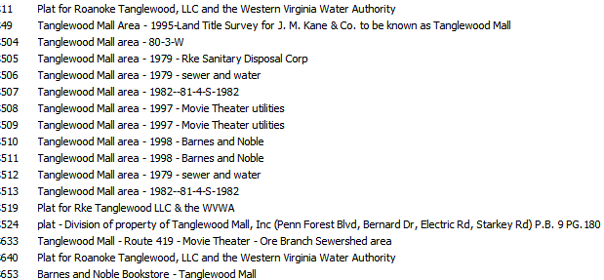



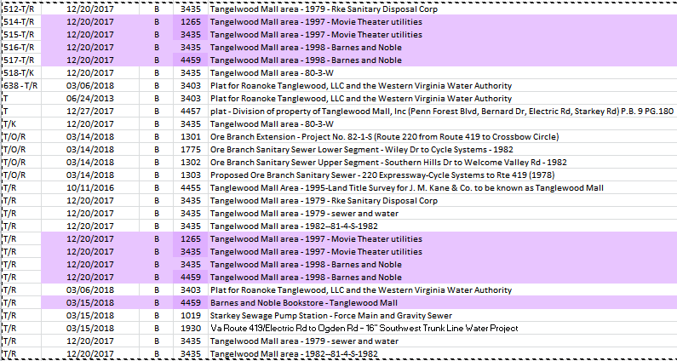 (ID #4459) 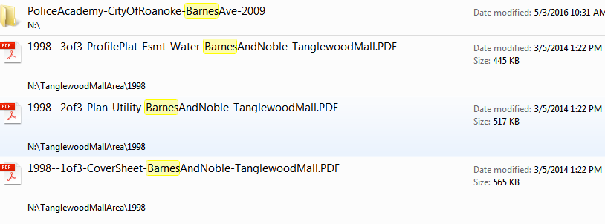 DONE

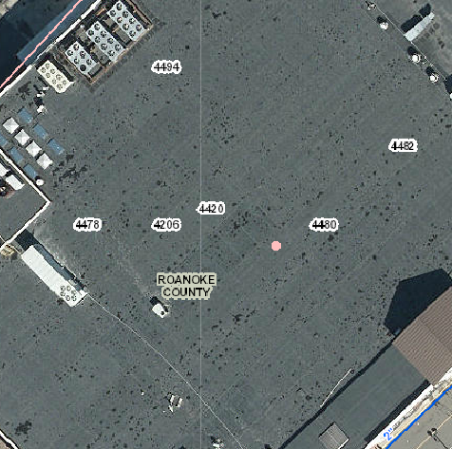 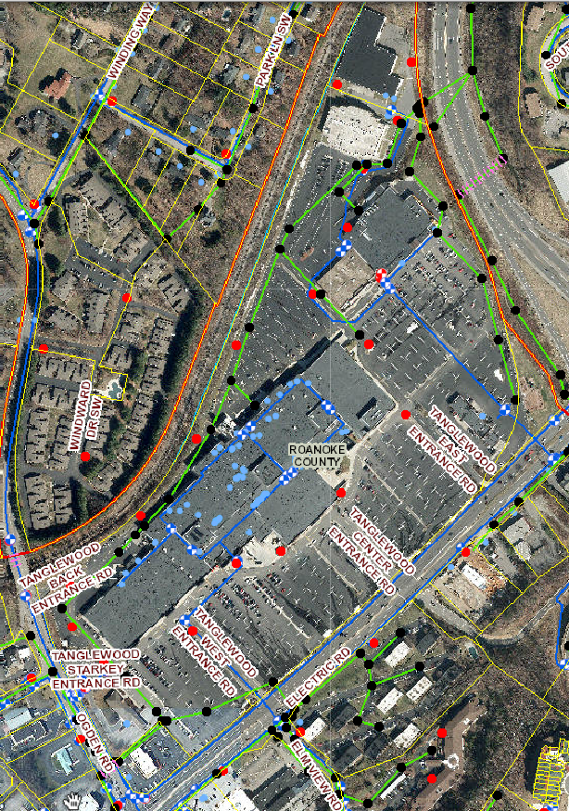

658 BRANDON AVE SW

662 BRANDON AVE SW

664 BRANDON AVE SW

670 BRANDON AVE SW

672 BRANDON AVE SW

676 BRANDON AVE SW

680 BRANDON AVE SW

682 BRANDON AVE SW

2009 COLONIAL AVE SW

2011 COLONIAL AVE SW

2013 COLONIAL AVE SW

2015 COLONIAL AVE SW

2017 COLONIAL AVE SW

2019 COLONIAL AVE SW

2021 COLONIAL AVE SW

2029 COLONIAL AVE SW

2031 COLONIAL AVE SW

2033 COLONIAL AVE SW

2035 COLONIAL AVE SW

2037 COLONIAL AVE SW

2043 COLONIAL AVE SW

2053 COLONIAL AVE SW

2057 COLONIAL AVE SW

2063 COLONIAL AVE SW

2071 COLONIAL AVE SW

2073 COLONIAL AVE SW

2103 COLONIAL AVE SW

2105 COLONIAL AVE SW

2111 COLONIAL AVE SW

2113 COLONIAL AVE SW

2115 COLONIAL AVE SW

2117 COLONIAL AVE SW

2119 COLONIAL AVE SW

2121 COLONIAL AVE SW T# 1270719

2123 COLONIAL AVE SW

2125 COLONIAL AVE SW

2127 COLONIAL AVE SW

2129 COLONIAL AVE SW

2133 COLONIAL AVE SW

2135 COLONIAL AVE SW A Little Bit Hippy

2143 COLONIAL AVE SW

2145 COLONIAL AVE SW

2201 COLONIAL AVE SW

2205 COLONIAL AVE SW

2207 COLONIAL AVE SW

2219 COLONIAL AVE SW

2221 COLONIAL AVE SW

2225 COLONIAL AVE SW

2229 COLONIAL AVE SW Mission BBQ

2235 COLONIAL AVE SW

2239 COLONIAL AVE SW FedEx

2243 COLONIAL AVE SW

4478 Electric Rd SW Barnes and Noble

4480 Electric Rd SW Firestone

4488 Electric Rd SW Kroger

4496 Electric Rd SW American Freight

Movie theater

Staples – Electric Rd

Belk

JC Penney

SteinMart

T.J. Maxx

Applebees

Crystal Cottage

Five Guys Burgers & Fries

K & W Cafeteria

Merle Norman

Miller Mottel Technical College

12/20/2017Tanglewood Mall Area – 1997 –FIND other sheets on County Scans

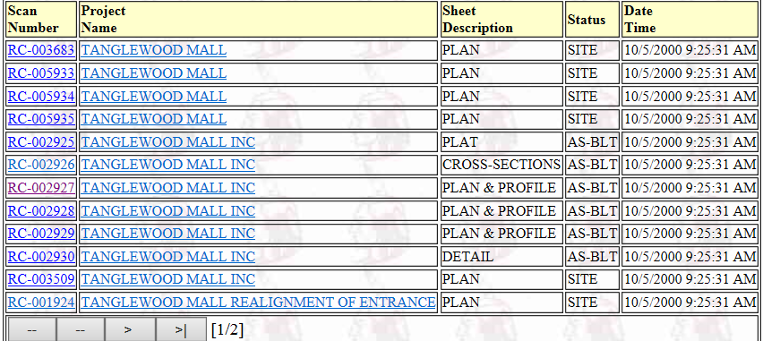

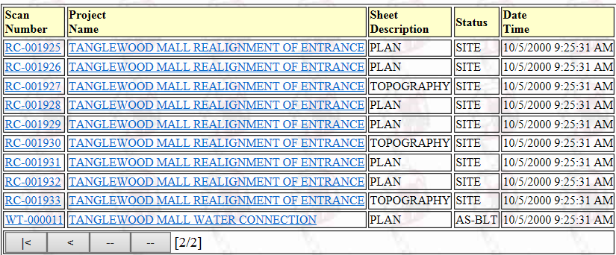

RC-003682 – RC-005935 Copied to Tanglewood folder:

**Northside 419**

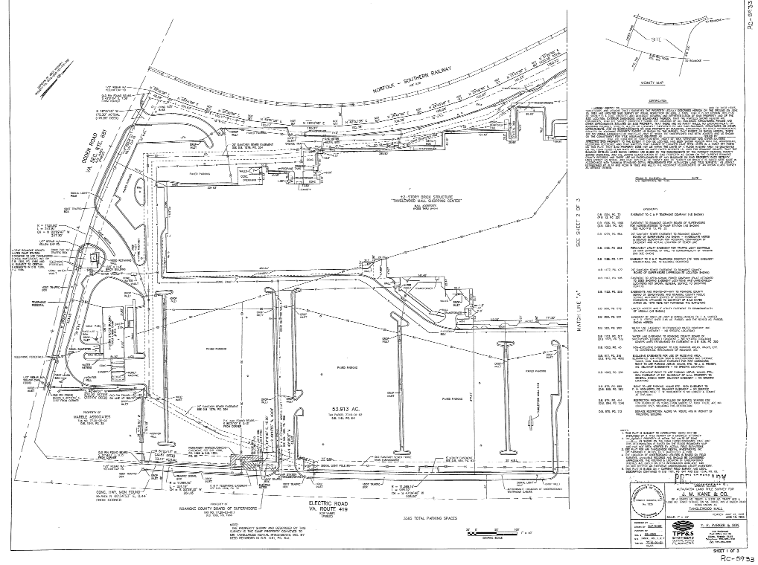 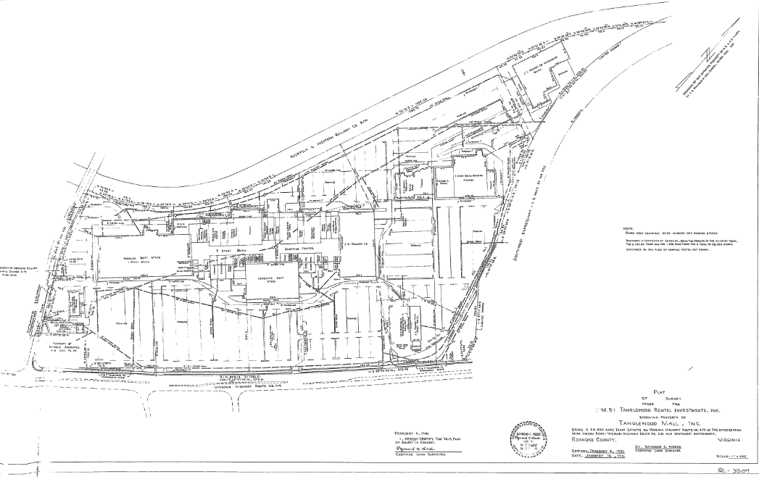

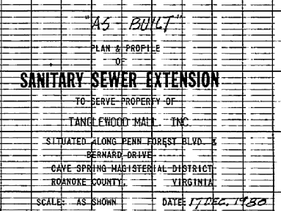 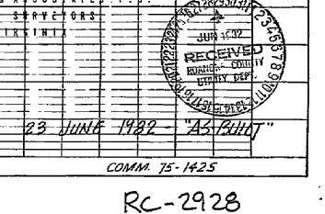 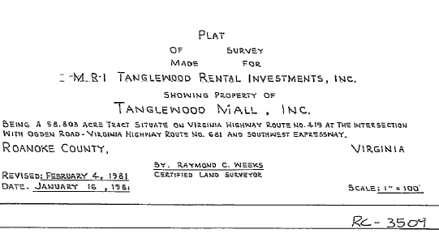 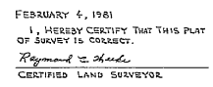

**ID 3403** 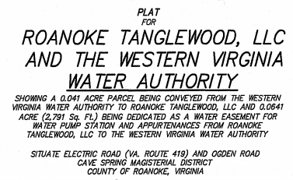   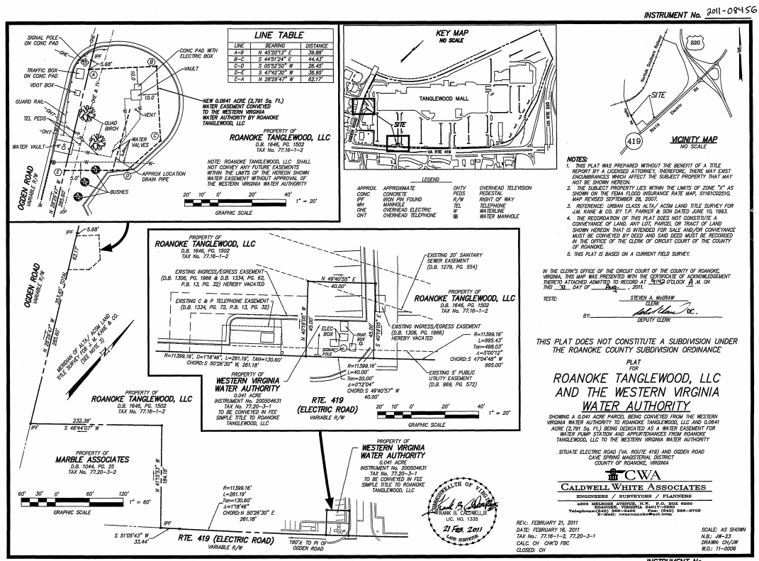

**Southside Electric Rd (Route 419)**

PB9 PG108 RC-002925Tanglewood Mall (PennForest&Starkey&Bernard)

