**Partial history info, photos, and proposal for the Gish Mill Property from various web articles (2020)**

350 Gus Nicks Blvd, Vinton, Virginia

Tax # 060.11-04-22.00-0000

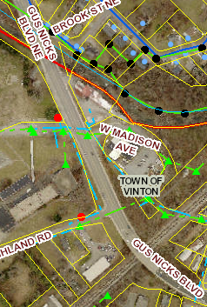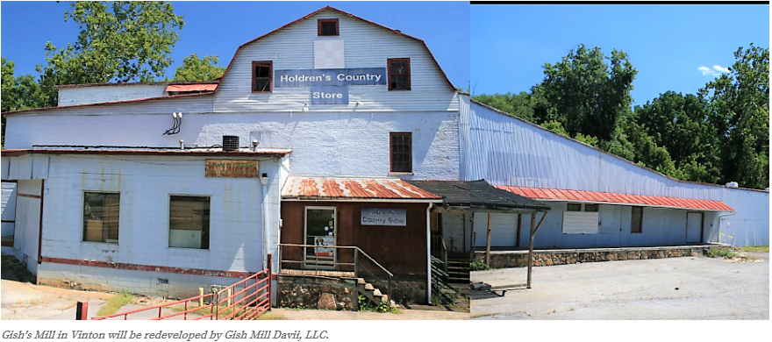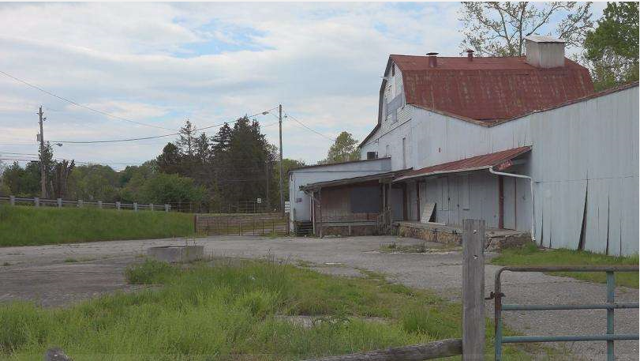

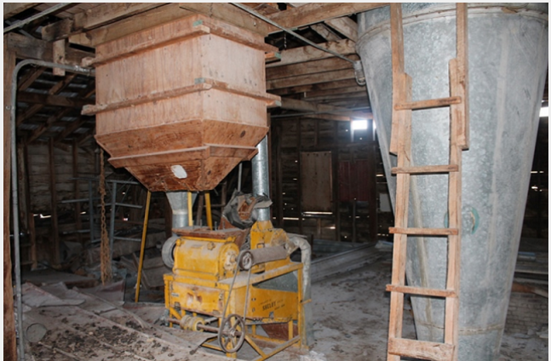 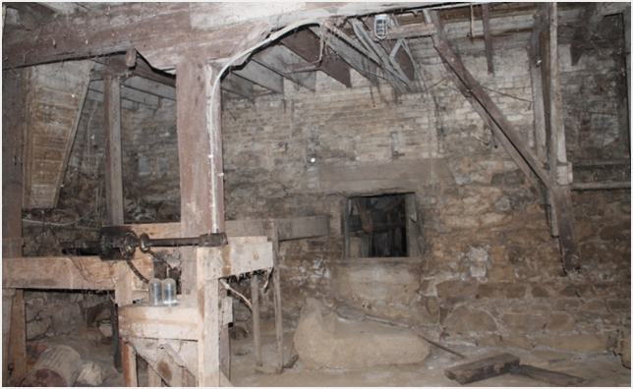 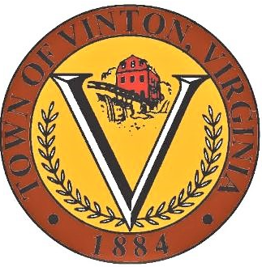

* Vinton's Gish Mill property is in the Town of Vinton. The mill is so iconic to the town that it is featured on the Town Seal.
* The 14,000-square-foot structure was a former gristmill, and farm supply retail and warehouse (Holdren’s Country Store) and had been operated continuously since the 1770s.
* In 2015, the town bought the property from the Holdren Family when they retired after operating the establishment for over 30 years
* Since 2015, the 1.15-acre site along Glade Creek has been largely empty.

David Hill (Landscape architect and president of Hill Studios) has teamed up with David Trinkle (former vice mayor of Roanoke, restaurateur, developer, and doctor) as Gish Mill Davii, LLC, to purchase the Gish’s Mill property on Gus Nicks Boulevard.

* Their plan is to convert the historic property into a mixed-use development to include a small restaurant, hospitality (five rental rooms with an Airbnb model), a basement speakeasy (for tasting spirits), and a local retail operation with locally sourced products—similar to a country store.

Vinton's Economic Development director is Richard "Pete" Peters.

"It’s a preservation project but making it more modern and current so that it could still function as a legitimate business and produce revenues.”

The site is a challenging one as it is situated on a flood plain.

According to Peters, in a best case scenario, they hope to start breaking ground by January 2021.