Waterfront Waterworks, Inc.
Showing Well Lots Surveyed 07/1985
Drainage Lot Surveyed 02/1986

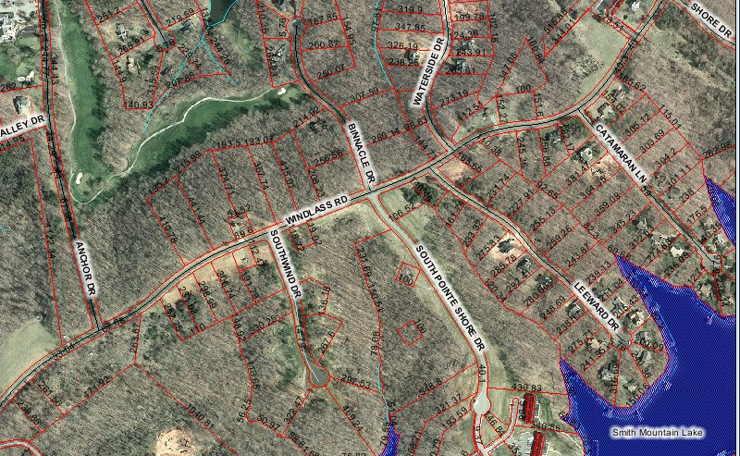

Well Lot 2 - T# 0310405400
Well Lot 13 - T# 0310405600
Well Lot 12 - T# 0310002005
Well Lot 3 - T# 0310002005
Well Lot 11 - T# 0310002004
Drain Field - T# 0310002005A

